
Hilderstone Parish Council Meeting

On Wednesday 23rd October 2024 at 7.30pm

Minutes of the meeting held at
Hilderstone Village Hall, Sandon Rd, Hilderstone, Stone ST15 8SF

Attendance:
Cllr J Davies (Chairman) Cllr A Stringer (Vice Chairman) Cllr P Higgins
Cllr J Crump Cllr M Shelley Cllr H Woodward
Cllr K Aspin (SBC) Nikola Evans – Clerk

Item No. | Agenda Item
1 | To record declarations of interest from members on any item to be discussed  Cllr A Stringer – Item 12
2 | To consider accepting apologies for absence and any reasons to be recorded.  None
3 | To approve the minutes of the last meeting held on 24th September 2024  Approved as a true record by all that attended.
4 | To adjourn the meeting to allow public participation  None
5 | To receive an update from Stafford Borough Councillor and Staffordshire County Councillor  Cllr K Aspin reported on the following:  - Solar farm @ Drointon Lane, have appealed the rejection of their planning application.  - 8k+ houses have been proposed on the new local plan.  - Demolition is due to start on the old Guild Hall.

Close the meeting to the public and continue with parish council business
6 | To discuss planning applications received  None to be discussed
7 | To review previously reported village issues on the clerk’s report.
   | Item | Date | Action
  1 | Severn Trent and Cotwalton Junction to B5066 ref: 4181743 & 4237100 - Missing bollards. 25.05.22 – still chasing. 22.03.23 – ongoing – 21.04.21 – W/O raised – 26.09.23 still unresolved  23.10.24 - Reported again - A highways officer has assessed the site you reported and arranged a non-urgent work instruction. The outcome of the assessment means this defect does not pose an immediate risk to public safety.  Our priority is to be effective at responding to the most serious problems on the network, therefore we are unable to provide a delivery date for defects of a non-urgent nature, until such time that resources become available. | 18.12.20 | Monitor  4181743 – closed  4237100 – open  4407342 – 24.09.24
  2 | Severn Trent Gate - Still has not been replaced – Cllr Woodward will see if she can obtain a contact from her source – clerk to write a letter – Severn Trent have been advised. – No further information has been received. 25.05.22 job number for Seven Trent to repair the gateway. 26.09.23 Still monitoring  23.10.24 – Still unresolved despite repeatedly reporting it to Severn Trent |  | Monitor  Ref: 2005645554
  3 | Damaged road sign by Roebuck.  18.05.23 – Inspected and W/O raised. 26.09.23 – still unresolved  23.10.24 – Still unresolved - As new high priority issues can arise on a daily basis, for this reason we are unable to provide a delivery date for defects of a non-urgent nature. Please be assured however that as all roads receive either monthly, quarterly or annual highway safety inspections, we will of course continue to monitor the problem you have reported. Does not pose a risk, do you want me to report again? | 13.05.22 | Monitor  Ref: 4281637
  4 | Issue type:  Road Signs - Damaged sign  Additional information  Road sign has been damaged by a road traffic accident.  Additional location information  Cross road on B5027  01.03.24 - A highways officer has assessed the site you reported and arranged a non-urgent work instruction  23.10.24 - We have not yet been able to coordinate resources to resolve the enquiry you raised, due to high demand for reactive maintenance work across our road network.  We write to assure you that we have not forgotten about the issue and will endeavour to schedule the necessary works as soon as is practicably possible. | 28.02.24 | Ref: 4373644
  5 | Damaged kerb stones – Dingle Lane Island  23.10.24 UNABLE TO ACTION - We have visited the location provided with your report but have been unable to identify any defects that require remedial works at this time.  It might be that the problem has now been resolved, however if you believe there is still an issue that requires attention, may we kindly ask that you contact us again with your reference number and a detailed location, (e.g. outside a property name/number or a street light number), so we can verify the details. | 19.09.24 | Ref: 4406974
  6 | Various Gullies, reported by Cllr Stringer | 26.09.24 | Refs:  4407270  4407271  4407272  4407274
  7 | Hall Lane – Road Damage  23.10.24 Work order raised | October 2024 | Ref: 4347586
8 | To discuss any new traffic and highways issues.  Concerns raised for the amount and size of HGV’s and agricultural vehicles traveling through the village, unfortunately there is no solution to this issue. Unsuitable for HGV signs are in place, however they are only advisory and do not have a weight limit warning on them.
9 | To discuss any new footpath and village Maintenance issues.  - Clerk to chase maintenance contractor regarding planters
10 | To note upcoming village Events  - Christmas Panto  - Monthly popup pub and café  - Christmas Tree Festival – Christ Church 7th & 8th December
11 | To approve monthly finance – RFO  - To approve items for payment - APPROVED  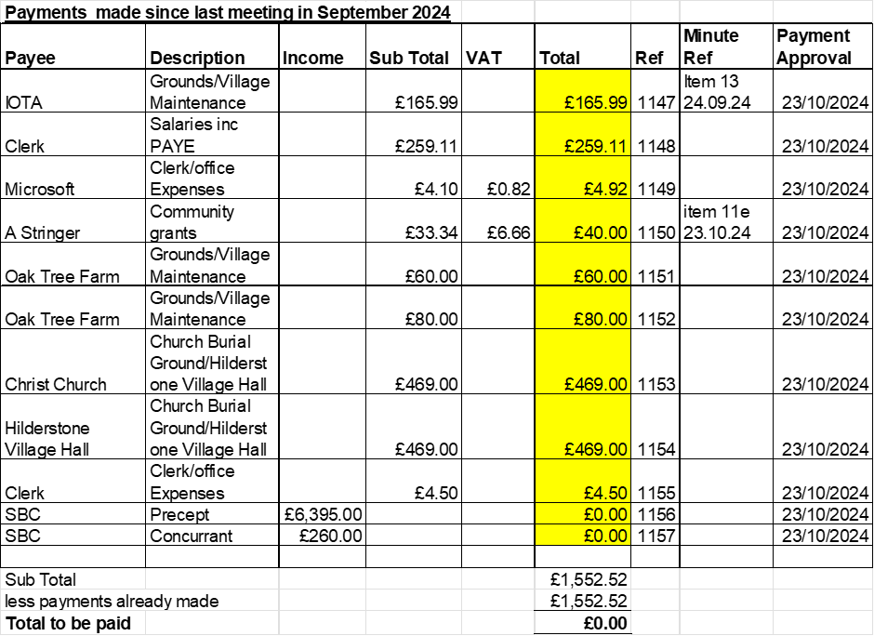  - To receive and approve monthly budget summary – circulated and approved  - To receive and approve monthly bank reconciliation – circulated and approved  - To receive and approve draft budget for 2025/26 – circulated and approved, Cllr Woodward proposed – Cllr Crump second, all in favour of not increasing the precept for 2025/26.  - To approve reimbursement for 2 x poppy wreath to Cllr A Stringer £40 - APPROVED
12 | To consider grant application received from Christ Church towards maintenance costs.  APPROVED – all in favour. The parish council also had a short discussion, to award a grant of £5,000 for help towards building toilets at the church. This was agreed in principle, the Church would need to formally request it and supply the council with all the necessary paperwork.
13 | Councillor Information and items for the next Agenda.  Cllr J Davies reported on the following:  - 8th November is the opening night for Stafford Crown Wharf Theatre – “Shakespeare in Love”  - Choral society concert to be held in Stone on 9th November, ticketed event.  - Choral Society Christmas Concert – 18th December, ticketed event.  - 21st November – Christmas light switch on in Stone.  Cllr Shelley reported on the following:  The memorial bench at the entrance to the village hall has been removed. This bench was donated by one of Cllr Shelly’s relatives, he has very kindly donated a new one and will install it soon.
14 | To agree a date for the next meeting  - 27th November 2024 – From 7:30pm @ Hilderstone Village Hall
15 | Meeting Closed – 21:00pm

