
Hilderstone Parish Council Meeting

On Tuesday 24th September 2024 at 7.30pm

Minutes of the meeting held at
Hilderstone Village Hall, Sandon Rd, Hilderstone, Stone ST15 8SF

Attendance:
Cllr J Davies (Chairman) Cllr A Stringer (Vice Chairman) Cllr P Higgins Cllr J Crump

Cllr K Aspin (SBC) 4 x MOP 2 x Guest speakers:
Robert Rowan, Openreach
Gary Fulton, Staffordshire County Council
Item No. | Agenda Item
1 | To record declarations of interest from members on any item to be discussed.  None received
2 | To consider accepting apologies for absence and any reasons to be recorded.  Cllr H Woodward & Cllr M Shelly, no apologies received
3 | To approve the minutes of the last meeting held on 23rd July 2024  Approved as a true record by all that attended
4 | To adjourn the meeting to allow public participation  Joined by 2x guest speakers who gave a small presentation to members of the public and the parish council, about a new community scheme recently launched to upgrade the broadband network for approximately 470 properties in the Hilderstone exchange area. Clerk to publisise literature and try to encurage residents to pledge their support.
5 | To receive an update from Stafford Borough Councillor and Staffordshire County Councillor  Cllr K Aspin – SBC reported on the following:  - Asylum seekers accommodation plans at Stafford University have been withdrawn, Serco are now looking for other sites.  - Solar farm planning application at Drointon Lane has been refused. SBC expect an appeal at a later date.  - Business innovation grants to help small business is open until 31st December 2024, more information can be found at https://www.staffordbc.gov.uk/business-innovation-grants  No report received from SCC.

Close the meeting to the public and continue with parish council business
6 | To discuss planning applications received  - 24/39625/TCA – Copes Croft, Sandon Rd, Hilderstone – 2x Maple (T1 & T2) 20% crown reduction.  No objections received.
7 | To review previously reported village issues on the clerk’s report.
   | Item | Date | Action
  1 | Severn Trent and Cotwalton Junction to B5066 ref: 4181743 & 4237100 - Missing bollards. 25.05.22 – still chasing. 22.03.23 – ongoing – 21.04.21 – W/O raised – 26.09.23 still unresolved  24.09.24 - Reported again | 18.12.20 | Monitor  4181743 – closed  4237100 – open  4407342 – 24.09.24
  2 | Severn Trent Gate - Still has not been replaced – Cllr Woodward will see if she can obtain a contact from her source – clerk to write a letter – Severn Trent have been advised. – No further information has been received. 25.05.22 job number for Seven Trent to repair the gateway. 26.09.23 Still monitoring  24.09.24 – Still unresolved despite repeatedly reporting it to Severn Trent |  | Monitor  Ref: 2005645554
  3 | Damaged road sign by Roebuck.  18.05.23 – Inspected and W/O raised. 26.09.23 – still unresolved  24.09.24 – Still unresolved - As new high priority issues can arise on a daily basis, for this reason we are unable to provide a delivery date for defects of a non-urgent nature. Please be assured however that as all roads receive either monthly, quarterly or annual highway safety inspections, we will of course continue to monitor the problem you have reported. Does not pose a risk. Clerk to report again | 13.05.22 | Monitor  Ref: 4281637
  4 | Damaged national speed limit sign – Dingle Lane  Reported to highways 23.10.23  23.11.23 A highways officer has assessed the site you reported and arranged a non-urgent work instruction. The outcome of the assessment means this defect does not pose an immediate risk to public safety.  Our priority is to be effective at responding to the most serious problems on the network, therefore we are unable to provide a delivery date for defects of a non-urgent nature, until such time that resources become available.  24.09.24 – RESOLVED on 12.08.24 | 23.10.2023 | Ref: 4347628
  5 | Issue type:  Road Signs - Damaged sign  Additional information  Road sign has been damaged by a road traffic accident.  Additional location information  Cross road on B5027  01.03.24 - A highways officer has assessed the site you reported and arranged a non-urgent work instruction  24.09.24 – Report from highways on 28.08.24 - We have not yet been able to coordinate resources to resolve the enquiry you raised, due to high demand for reactive maintenance work across our road network.  We write to assure you that we have not forgotten about the issue and will endeavour to schedule the necessary works as soon as is practicably possible. | 28.02.24 | Ref: 4373644
  6 | Issue type:  Road Damage-Pothole  Approximate size (width, depth etc.) *  approx. 11 cm deep  Additional location information  Cycle Lane. Half way between Moss Lane and Hall Lane on the Creswell Road coming out of Hilderstone Village.  22.03.24 @ 16:08 - A highways officer has assessed the site and an urgent work instruction has been raised. Works of this nature are usually carried out within seven days and 98% of the most serious defects are made safe within 24 hours.  24.09.24 – RESOLVED 27.06.24 – Works completed | 15.03.24 | Ref: 4377848
  7 | Damaged kerb stones – Dingle Lane Island | 19.09.24 | Ref: 4406974
8 | To discuss any new traffic and highways issues.  - Cllr A Stringer has reported a number of blocked gullies within the village, she will provide the clerk with reference numbers to add to our list of ongoing works.
9 | To discuss any new footpath and village Maintenance issues.  - New village maintenance contract  Cllr J Davies met with representatives of OTF, they provided a satisfactory quote, council approved initial works to be carried out @ £1,008 then £1,201.87 for the annual maintenance programme starting from Spring 2025, plus additional £150 for village gate planters (plants & ongoing maintenance) and £155.08 for Village Green maintenance.  - Telephone box is reported to be overrun with books – clerk to contact volunteer to have a clean out.  - Clerk to contact volunteer to dispose of the planter next to the telephone box, parish council will consider replacing with a new planter after it has been removed.
10 | To note upcoming village Events  - Monthly pop-up pub  - Christmas panto  - Councillors discussed the event that took place at Black Birch Farm, “The Great Hilderstone Hoedown” The parish council were disappointed the organisers didn’t think to inform local residents about this event and are concerned local residents cannot object to these events being held. After doing research it seems the organisers are not obliged to let anyone know, however we would have thought they would out of courtesy. The parish council wonders if this rule is a Stafford Borough ruling or is it nationwide? Cllr Aspin will investigate.
11 | To approve monthly finance – RFO  - To approve items for payment – APPROVED  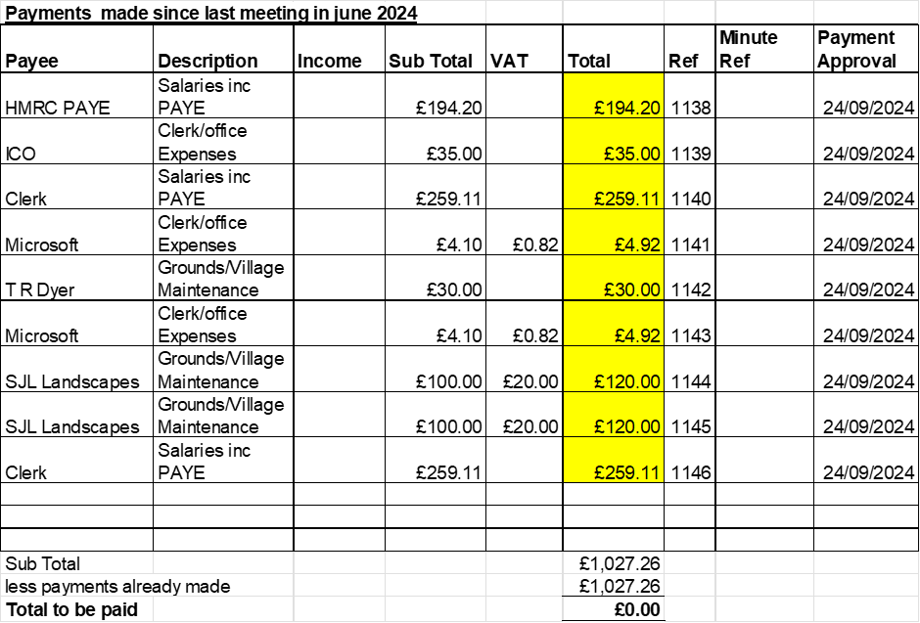  - To receive and approve monthly budget summary - Circulated and APPROVED  - To receive and approve monthly bank reconciliation - Circulated and APPROVED
12 | To approve new Grievance and disciplinary procedure.  ADOPTED
13 | To approve purchasing new planter by chapel.  Approved to buy a new planter, clerk to reach out to Oak Tree Farm to see if they will plant up and maintain. Budget approved £350.
14 | Councillor Information and items for the next Agenda.  Cllr J Davies reported on the following:  - Heritage Centre, planned to open before the first night of Ston & Crown Wharf Theatre.  Items for next agenda:  - Approval to buy two remembrance wreaths.
15 | To agree a date for the next meeting  - Wednesday 23rd October 2024 at Hilderstone Village Hall  - Consider changing meetings back to Wednesday from October. – APPROVED, clerk to provide new dates for noticeboards.
16 | Meeting Closed – 21:10pm

