
Hilderstone Parish Council Meeting

On Tuesday 26th March 2024 at 7.30pm

Minutes of the meeting held at
Hilderstone Village Hall, Sandon Rd, Hilderstone, Stone ST15 8SF

Attendance:
Cllr J Davies (Chairman) Cllr A Stringer (Vice Chairman) Cllr J Crump Cllr P Higgins Cllr M Shelly Cllr M O’donoghue

Nikola Evans – clerk Cllr K Aspin - SBC

Item No. | Agenda Item
1 | To consider accepting apologies for absence and any reasons to be recorded.  Cllr H Woodward – other commitments, accepted
2 | To approve the minutes of the last meeting held on 27th February 2024  Approved as a true record of events by all that attended
4 | To record declarations of interest from members on any item to be discussed  None received
5 | To adjourn the meeting to allow public participation  None attended
6 | To receive an update from the local PCSO  None attended
7 | To receive an update from the Borough Councillor  Cllr Aspin provided the parish council with a ward report – see appendix 1 and also reported on the following:  - Hilderstone will be in the Great Wyrley constituency and Trent Vally ward for the county.  - The new park, Westbridge in Stone will be opened by the Mayor of Stafford.  - A entertainments licence for Kibble park has been granted.
8 | To receive an update from the County Councillor  None attended

Close the meeting to the public and continue with parish council business
9 | To discuss planning applications received  - 24/38777/HOU The Cottage Whitesytch Lane – Demolition of existing conservatory, porch and carport plus proposed extensions with external alterations and internal re-modelling. – No objections received
10 | To review previously reported village issues on the clerk’s report.
   | Item | Date | Action
  1 | Severn Trent and Cotwalton Junction to B5066 ref: 4181743 & 4237100 - Missing bollards. 25.05.22 – still chasing. 22.03.23 – ongoing – 21.04.21 – W/O raised – 26.09.23 still unresolved | 18.12.20 | Monitor  4181743 – closed  4237100 - open
  2 | Severn Trent Gate - Still has not been replaced – Cllr Woodward will see if she can obtain a contact from her source – clerk to write a letter – Severn Trent have been advised. – No further information has been received. 25.05.22 job number for Seven Trent to repair the gateway. 26.09.23 Still monitoring |  | Monitor  Ref: 2005645554
  3 | Erosion of bank opposite church buildout - Clerk has reported to highways, believed due to wide vehicles using the road churning up the kerb side. Children are having to walk in it, and it could potentially block the drains. 23.03.22 – No further information has been received.  26.09.23 – Still monitoring | 23.02.22 | Monitor  Report again, record reference no.
  4 | Damaged road sign by Roebuck.  18.05.23 – Inspected and W/O raised. 26.09.23 – still unresolved | 13.05.22 | Monitor  Ref: 4281637
  5 | Water spring, by buildout on Roebuck Bank. Concern has been raised, when temperature drops this will cause ice on the roads causing danger to vehicles. Needs reporting before anything happens.  22.02.23 highways visited site, could not find anything wrong or locate the spring. Suggested Cllrs take pictures to provide more evidence. 26.09.23 SCC have reported it to a third party for repair, they will continue to monitor it as part of their routine inspections. Clerk to see if we can find out who the third party is. 23.10.23 unable to find any information – its located on someone’s property | 26.10.22 | Monitor  Ref: 4298332
  6 | Play area, wetpour has shrunk and is now causing trip hazard, clerk to report to Stafford Borough Council. Reported to SCC. 26.04.23 – clerk to check it is SCC who own the park, possible SBC are responsible for it. Clerk to continue to report to SBC 26.09.23 clerk to chase – 28.09.23 – Streetscene advised they have added it to their team for action. | 23.11.22 | Clerk
  7 | Bridle way Rural 14 is currently not up to the legal standard and unusable. It is not accessible for a horse or Rider. Unable to access the Bridleway all year round, not maintained.  The narrow path that that runs along the side of the ploughed field, is not 3 Meters wide, or high, you cannot see underfoot. Dangerous for horses and riders’ safety.  30.03.23 – update - Your enquiry has been assessed as: P&C (Ploughing and Cropping). Providing you have provided the information below we aim to contact the landowner within 14 days. • A photo (if possible) of the obstructed path and details as to the location where the photo was taken. • Details for the landowner (if known). Requested photos from complaint originator.  26/09/23 – Still unresolved | 29.03.23 | Reported to ROW  Ref: 230396410 – Rural 14  Type: Obstruction/Other  Details:  Reference Code: 19021  Grid Reference: SJ93653648  Parish: Stone Rural CP
  8 | Damaged national speed limit sign – Dingle Lane  Reported to highways 23.10.23  23.11.23 A highways officer has assessed the site you reported and arranged a non-urgent work instruction. The outcome of the assessment means this defect does not pose an immediate risk to public safety.  Our priority is to be effective at responding to the most serious problems on the network, therefore we are unable to provide a delivery date for defects of a non-urgent nature, until such time that resources become available. | 23.10.2023 | Ref: 4347628
  9 | ROW signpost – Cotwalton Lane meets Hilderstone Road on footpath 10 is damages. Clerk reported to ROW | 24.10.2023 | Ref: 231093710
  10 | No3 Farm Lea, very untidy front and back garden, full of various waste. | 22.11.2023
  11 | Creswell Road signage for horse and riders  Road is well used by horse riders, there has been a couple of near misses, here are a number of liver yards/horse yard in the vicinity, it would be helpful to have signage to warn motorists about potential horse and  riders as currently there is nothing. | 07.01.2024 | Reported to Cllr Ian Parry – 08.01.24  Reported to Highways – 21.01.24
  12 | Logged On: 16/02/2024  Request Type: Drain Blocked Gully  Location: HILDERSTONE ROAD, HILDERSTONE  Current Status: Ongoing | 16.02.23 | Ref: 4369981
  13 | Issue type:  Road Signs - Damaged sign  Additional information  Road sign has been damaged by a road traffic accident.  Additional location information  Cross road on B5027 | 28.02.24 | Ref: 4373644
  14 | Issue type:  Road Damage-Pothole  Approximate size (width, depth etc.) *  approx. 11 cm deep  Additional location information  Cycle Lane. Half way between Moss Lane and Hall Lane on the Creswell Road coming out of Hilderstone Village.  22.03.24 @ 16:08 - A highways officer has assessed the site and an urgent work instruction has been raised. Works of this nature are usually carried out within seven days and 98% of the most serious defects are made safe within 24 hours. | 15.03.24 | Ref: 4377848
11 | To discuss any new traffic and highways issues.  - Flooding by Daniel Eaton Tractors, clerk to report  - Large pothole by Marley Holllars and Mount Pleasant Farm, clerk to report  - Blocked gully, Creswell Road at the Bird in hand crossroads. Clerk to report  - 30mph sign needs reseating by spot acre road, outbound on RH side. Clerk to report
12 | To discuss any new footpath and village Maintenance issues.  None reported
13 | To note upcoming village Events  - Hilderstone Village Hall – AGM – 2nd April 2024 at 19:30
14 | To discuss relacing the planters on Roebuck Bank  Clerk presented options to the parish council, approved to use current grounds maintenance contractors, SJL Landscapes. £2,120 + VAT for planters, delivery and installation.
15 | To approve monthly finance – RFO  - To approve items for payment – Approved  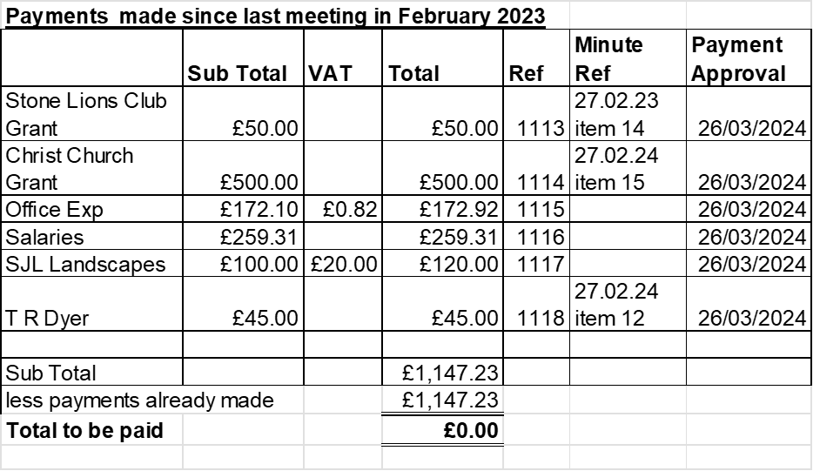  - To receive and approve monthly budget summary – Circulated before the meeting and approved  - To receive and approve monthly bank reconciliation - Circulated before the meeting and approved
16 | Councillor Information and items for the next Agenda.  Councillors reported the new windows on the upper floor of Lower Farm House are PVC, should be wooden. The house is a listed building and on a conservation area. Clerk to investigate.  Cllr J Davies reported the following:  - Stone carnival will not take place this year, neither will the Eccleshaw show.  - Band concert and D Day event will take place at the park in Stone.  - Heritage Centre is due to open soon.
17 | To agree a date for the next meeting  - Tuesday 23rd April 2024 from 7:30pm @ Hilderstone Village Hall
18 | Meeting Closed – 20:30pm

Appendix 1

Milwich Ward Member Report to Parish Councils. For Members, Meetings and wider distribution.

MARCH 2024

In no order, we highlight:

A SBC matters

- Annual audit of the council’s carbon footprint. A new report illustrates Stafford Borough Council’s overall carbon footprint for 2022-2023. The report shows a reduction, from 2285 tCO2e in 2022 to 1306 tCO2e in 2023.
- The Council adopted its Climate Change Adaptation Strategy in January 2023. Work to progress the delivery of the actions is underway. This includes projects looking to provide nature-based solutions to climate change on council owned green spaces; Another is looking to encourage businesses to consider how future impacts of climate change might impact their premises and operations. Work continues to increase the roll out of Electric Vehicle Charge Points; and a Local Area Energy Plan has been produced which identifies areas for the roll out of renewable energy within the Borough.
- Local Plan next stage – The LP has stalled due to change of control at the council and new government guidelines on the process and timetable for producing local plans. It seems likely there will be a fresh round of consultations. A reminder of our current position:
- The council will ‘go for growth’ on the basis that developers would attempt building on unsuitable sites without a ‘masterplan’.
- Preferred option sites are identified. Our Housing Monitor sets out available housing sites on greenfield and brownfield land, together with information about the percentage of delivery on such lands in recent years. Information on employment land sites is available - the Authority Monitoring Report. This includes affordable housing and statistics.
- The council also keeps a Register of Brownfield Land: Brownfield Land Register | Stafford Borough Council (staffordbc.gov.uk).
- We have no plans to build in the Green Belt.
We will keep in touch with PCs when the new plan is published, which we are told is imminent. There will be implications for the villages, either those wanting development or trying to curtail it.

- New government rules and guidance: A major tool to help towns and cities turn greener was launched in February by Natural England. Stafford BC awaits the detail and will assess the implications for planning and design. Aimed at planners and developers, the Green Infrastructure Framework will help increase the amount of green cover to 40% in urban residential areas. The accompanying Design Guide will support local planning authorities and developers design and create more nature-rich urban greenspaces to meet mandatory Biodiversity Net Gain requirements and support the development of the Nature Recovery Network. A Green Infrastructure Strategy now supports the National Planning Policy Framework’s new requirement that local authorities must develop strategic policies for green infrastructure. We will be developing a delivery plan to support the creation and enhancement of new and existing greenspaces. It will incorporate nature recovery, urban greening, tree cover, green space. Details are awaited.

- Biodiversity Net Gain. This is the new obligation on developers to incorporate minimum 10% of land for biodiversity, through planning permissions. A county wide Biodiversity Strategy Progress and County Local Nature Recovery Strategy will sit over the awaited Biodiversity Net Gain requirements. SBC will need to produce our own local design codes and strengthen our team to respond to the new environmental framework for planning.
- Street Cleaning. A woman has been taken to court by SBC and fined, thanks to a resident who filmed her in the act. The side streets in our towns are not always very clean as we point out to officers. The local communities in our villages, as we know, do a terrific job of litter clearing. We continue to participate in the annual national Performance Benchmarking for Street Cleansing and Parks and Open Spaces. SBC were shortlisted for “Best Performer” in Street Cleansing category again. The Council did not pick up the award but was pleased with the recognition. The council will support Community groups undertaking litter picks, throughout the borough.
- Stafford Hgh Street regeneration: the market square renovation and impending work to improve the aspect of the station frontage, are part of the Future High Streets Fund awarded three years ago. The council has bought the old Co-op building to take forward the regeneration of the north end of the high street, with residential and retail development; and has finally acquired the Guildhall. Its frontage will remain – it’s listed – the rest likely to be a combination of retail and residential. We have not been informed of a decision on possible relocation of the indoor market.
- Solar Farms applications: These are major applications, which will always go to planning committee, but we will call them in none the less in order to articulate views from the communities in particular; always mindful that each application will be dealt with on its merits. At time of writing, the Hanyards application has been deferred by committee for further information; the Drointon application awaits its day.

B The Cannock Chase Destination Access guide is available as a download here with information on the accessible facilities available at 21 different locations including the visitor centres and cafes. Shugborough Estate and other attractions, trails, nature reserves and car parks are included.. It gives visitors information on accessible leisure activities that can be visited if you have a disability, require assistance with access, adaptable bikes, or a parent and guardian with small children and a buggy.

C Defra Farming in Protected Landscapes Fund (FIPL): There is a significant amount of money available for the next three years, for valid farm and land-based projects, large and small, within the radius of the Chase. The link below details some projects that have taken place so far. More will be added as they are completed, so please do visit from time to time to see the projects as they progress and share it with anyone who you think may be interested in applying. Farming in Protected Landscapes - Cannock Chase AONB (cannock-chase.co.uk). Runs until March 2025 and will fund projects that support nature recovery; mitigate the impacts of climate change; provide opportunities for people to discover; enjoy and understand the landscape and its cultural heritage; support nature-friendly, sustainable farm businesses.

D Special Area of Conservation (SAC). Managed by SBC for five authorities. This is a requirement on developers within a 15km radius of Cannock Chase to contribute financially to the protection of the internationally important SAC. It was welcome that a planning application submitted by the National Trust to deliver new visitor facilities at Shugborough was recently approved. It is supported by SAC funding. Initial studies for the Punchbowl car park redevelopment are due this Spring 2024 and education engagement projects are progressing.

E Village Halls small grants – DEFRA & ACRE. The grant fund has now re-opened to new applicants who wish to undertake smaller projects such as disability access, toilet upgrades and new kitchens. Grant awards of between £2,000 to £5,000, and up to 20 per cent of eligible project costs, are on offer. Project expenditure must take place before 31 March 2025. The fund is expected to stay open until December 2024, however it may be withdrawn before this.
F Defibrillators grant for community spaces like town halls, local parks or post offices. The DHSC Community Automated External Defibrillator (CAED) Fund will support provision of 2000 AEDs. These will be distributed across England during 2023-2024, supporting any organisation based in England that is not eligible for the current Department of Education AED programme. Closing date: 21 September 2024
Happy Easter to all!
Cllr Frances Beatty: 01785 240667/07877 896466 fbeatty@staffordbc.gov.uk
Cllr Karine Aspin: 07498 325374 kaspin@staffordbc.gov.uk

