
Hilderstone Parish Council Meeting

On Tuesday 25th June 2024 at 7.30pm

Minutes of the meeting held at
Hilderstone Village Hall, Sandon Rd, Hilderstone, Stone ST15 8SF

Attendance:
Cllr J Davies (Chairman) Cllr A Stringer (Vice Chairman) Cllr P Higgins Cllr M Shelley Cllr M O’Donoghue
Cllr K Aspin (SBC)

Apologies:
Cllr J Crump Cllr H Woodward Nikola Evans – clerk

Item No. | Agenda Item
1 | To record declarations of interest from members on any item to be discussed  None made
2 | To consider accepting apologies for absence and any reasons to be recorded.  Cllr J Crump  Nikola Evans
3 | To approve the minutes of the previous meeting held on 28th May 2024  Approved as a true record by all that attended
4 | Adjourn for public participation
5 | Receive updates from SBC and SCC  Cllr K Aspin (SBC) gave a verbal update  Cllr I Parry (SCC) was not present
6 | Close the adjournment and discuss planning applications received  23/38051/FUL – Land at the rear of Jesmonde, amended plans submitted  It was considered that the amended planning application made no changes that addressed the concerns expressed by the Council when the application had been considered previously. The concerns would be reiterated.
7 | To review previously reported village issues on the clerk’s report.
   | Item | Date | Action
  1 | Severn Trent and Cotwalton Junction to B5066 ref: 4181743 & 4237100 - Missing bollards. 25.05.22 – still chasing. 22.03.23 – ongoing – 21.04.21 – W/O raised – 26.09.23 still unresolved | 18.12.20 | Monitor  4181743 – closed  4237100 - open
  2 | Severn Trent Gate - Still has not been replaced – Cllr Woodward will see if she can obtain a contact from her source – clerk to write a letter – Severn Trent have been advised. – No further information has been received. 25.05.22 job number for Seven Trent to repair the gateway. 26.09.23 Still monitoring |  | Monitor  Ref: 2005645554
  3 | Erosion of bank opposite church buildout - Clerk has reported to highways, believed due to wide vehicles using the road churning up the kerb side. Children are having to walk in it, and it could potentially block the drains. 23.03.22 – No further information has been received.  26.09.23 – Still monitoring | 23.02.22 | Monitor  Report again, record reference no.
  4 | Damaged road sign by Roebuck.  18.05.23 – Inspected and W/O raised. 26.09.23 – still unresolved | 13.05.22 | Monitor  Ref: 4281637
  5 | Water spring, by buildout on Roebuck Bank. Concern has been raised, when temperature drops this will cause ice on the roads causing danger to vehicles. Needs reporting before anything happens.  22.02.23 highways visited site, could not find anything wrong or locate the spring. Suggested Cllrs take pictures to provide more evidence. 26.09.23 SCC have reported it to a third party for repair, they will continue to monitor it as part of their routine inspections. Clerk to see if we can find out who the third party is. 23.10.23 unable to find any information – its located on someone’s property | 26.10.22 | Monitor  Ref: 4298332
  6 | Play area, wetpour has shrunk and is now causing trip hazard, clerk to report to Stafford Borough Council. Reported to SCC. 26.04.23 – clerk to check it is SCC who own the park, possible SBC are responsible for it. Clerk to continue to report to SBC 26.09.23 clerk to chase – 28.09.23 – Streetscene advised they have added it to their team for action. | 23.11.22 | Clerk
  7 | Bridle way Rural 14 is currently not up to the legal standard and unusable. It is not accessible for a horse or Rider. Unable to access the Bridleway all year round, not maintained.  The narrow path that that runs along the side of the ploughed field, is not 3 Meters wide, or high, you cannot see underfoot. Dangerous for horses and riders’ safety.  30.03.23 – update - Your enquiry has been assessed as: P&C (Ploughing and Cropping). Providing you have provided the information below we aim to contact the landowner within 14 days. • A photo (if possible) of the obstructed path and details as to the location where the photo was taken. • Details for the landowner (if known). Requested photos from complaint originator.  26/09/23 – Still unresolved | 29.03.23 | Reported to ROW  Ref: 230396410 – Rural 14  Type: Obstruction/Other  Details:  Reference Code: 19021  Grid Reference: SJ93653648  Parish: Stone Rural CP
  8 | Damaged national speed limit sign – Dingle Lane  Reported to highways 23.10.23  23.11.23 A highways officer has assessed the site you reported and arranged a non-urgent work instruction. The outcome of the assessment means this defect does not pose an immediate risk to public safety.  Our priority is to be effective at responding to the most serious problems on the network, therefore we are unable to provide a delivery date for defects of a non-urgent nature, until such time that resources become available. | 23.10.2023 | Ref: 4347628
  9 | ROW signpost – Cotwalton Lane meets Hilderstone Road on footpath 10 is damages. Clerk reported to ROW | 24.10.2023 | Ref: 231093710
  10 | No3 Farm Lea, very untidy front and back garden, full of various waste. | 22.11.2023
  11 | Creswell Road signage for horse and riders  Road is well used by horse riders, there has been a couple of near misses, here are a number of liver yards/horse yard in the vicinity, it would be helpful to have signage to warn motorists about potential horse and  riders as currently there is nothing. | 07.01.2024 | Reported to Cllr Ian Parry – 08.01.24  Reported to Highways – 21.01.24
  12 | Logged On: 16/02/2024  Request Type: Drain Blocked Gully  Location: HILDERSTONE ROAD, HILDERSTONE  Current Status: Ongoing | 16.02.23 | Ref: 4369981
  13 | Issue type:  Road Signs - Damaged sign  Additional information  Road sign has been damaged by a road traffic accident.  Additional location information  Cross road on B5027  01.03.24 - A highways officer has assessed the site you reported and arranged a non-urgent work instruction | 28.02.24 | Ref: 4373644
  14 | Issue type:  Road Damage-Pothole  Approximate size (width, depth etc.) *  approx. 11 cm deep  Additional location information  Cycle Lane. Half way between Moss Lane and Hall Lane on the Creswell Road coming out of Hilderstone Village.  22.03.24 @ 16:08 - A highways officer has assessed the site and an urgent work instruction has been raised. Works of this nature are usually carried out within seven days and 98% of the most serious defects are made safe within 24 hours. | 15.03.24 | Ref: 4377848
  15 | Gullies – Multiple, raised by Cllr Stringer | 16.04.24 | Ref: 4384307
 | • All the entries in the list needed to be updated in preparation for a review in the autumn followed by official hastening of outstanding matters. Entry no 1 now merited a formal letter from the Chairman to Severn Trent. Entry no 4 required clarifications; it was believed that there was also a damaged road sign near the footpath opposite the Roebuck and that the 30-mph limit sign on entering the village from Meir Heath needed attention.
8 | To discuss any new traffic and highways issues.  • There was a plethora of road closures in the area at the moment. More informative signage and better warning would be helpful.
9 | To discuss any new footpath and village Maintenance issues.  • It was agreed that clarification was required regarding the various planters around the village. The asset register entries need to be verified for completion and accuracy, also, the names of those who have assumed responsibility for the maintenance of each planter should be added.  • There was continuing concern about deterioration to The Roebuck. It was understood that The Roebuck had been offered for sale but no evidence could be found. The Chairman would check with a contact in the commercial property world.
10 | To note upcoming village Events  On Saturday 29 June 2024:  Community Café 10:00 to 13:00  Pop-Up Pub with food from ‘The Curry Den’ 18:00 to 22:30
11 | To approve monthly finance – RFO  - Approval items for payment - circulated and approved  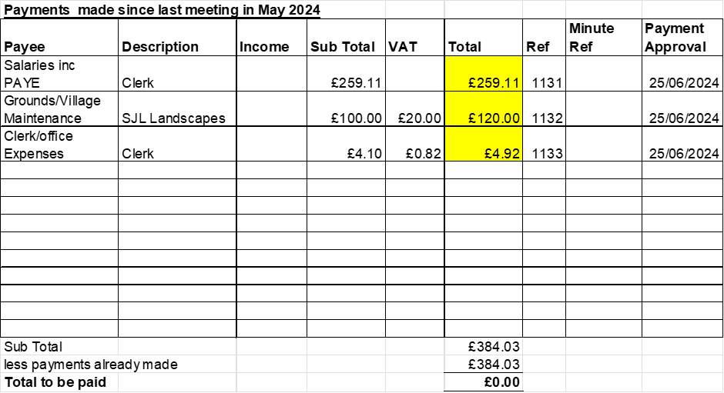  - Receive and approve monthly budget summary - circulated and approved  - Receive and approve monthly bank reconciliation - circulated and approved
12 | Councillor Information and items for the next Agenda.  Cllr J Davies advised the following:  - Stone Area Parish Liaison Group meeting – 19 May 24 included John Holmes, head of planning.  - On 9th June a small service of commemoration was held in Stone for the 6 men from the Stone area (including Frank Spencer from Hilderstone) who lost their lives during OVERLORD. Rose Mardling (Frank Spencer’s niece) attended.  - 11th June saw a very successful ‘soft’ opening of the Heritage Centre in Stone. Further developments were underway.
13 | To agree a date for the next meeting  - 23rd July 2024 from 7.30pm
14 | Meeting Closed –

