
Hilderstone Parish Council Meeting

On Tuesday 23rd July 2024 at 7.30pm

Minutes of the meeting held at
Hilderstone Village Hall, Sandon Rd, Hilderstone, Stone ST15 8SF

Attendance:
Cllr J Davies (Chairman) Cllr A Stringer (Vice Chairman) (arrived @ 19:50pm) Cllr P Higgins Cllr M Shelley
Cllr M O’Donoghue Cllr J Crump
Cllr H Woodward

Cllr K Aspin (SBC)

Item No. | Agenda Item
1 | To record declarations of interest from members on any item to be discussed  None received
2 | To consider accepting apologies for absence and any reasons to be recorded.  None, all attended
3 | To approve the minutes of the last meeting held on 25th June 2024  Approved as a true record by all that attended
4 | To adjourn the meeting to allow public participation  None attended
5 | To receive an update from Stafford Borough Councillor and Staffordshire County Councillor  Cllr K Aspin (SBC) advised the following:  - Solar farm planning applications are being approved, Drointon is going to committee on 31st July.  - New MP – Gavin Williamson  - For 2025 county elections, Hilderstone will be in the Trent Valley division.

Close the meeting to the public and continue with parish council business
6 | To discuss planning applications received  - 24/39266/TCA – Bank Cottage, Dingle Lane, Hilderstone. Removal of maple tree and stump. – The parish council can see no clear reason for removal, if the tree is undermining foundations or deceased and dangerous that would be acceptable, however if its blocking light, we suggest pruning.
7 | To review previously reported village issues on the clerk’s report.  All the entries in the list needed to be updated in preparation for a review in the autumn followed by official hastening of outstanding matters. Clerk to action
   | Item | Date | Action
  1 | Severn Trent and Cotwalton Junction to B5066 ref: 4181743 & 4237100 - Missing bollards. 25.05.22 – still chasing. 22.03.23 – ongoing – 21.04.21 – W/O raised – 26.09.23 still unresolved | 18.12.20 | Monitor  4181743 – closed  4237100 - open
  2 | Severn Trent Gate - Still has not been replaced – Cllr Woodward will see if she can obtain a contact from her source – clerk to write a letter – Severn Trent have been advised. – No further information has been received. 25.05.22 job number for Seven Trent to repair the gateway. 26.09.23 Still monitoring |  | Monitor  Ref: 2005645554
  3 | Erosion of bank opposite church buildout - Clerk has reported to highways, believed due to wide vehicles using the road churning up the kerb side. Children are having to walk in it, and it could potentially block the drains. 23.03.22 – No further information has been received.  26.09.23 – Still monitoring | 23.02.22 | Monitor  Report again, record reference no.
  4 | Damaged road sign by Roebuck.  18.05.23 – Inspected and W/O raised. 26.09.23 – still unresolved | 13.05.22 | Monitor  Ref: 4281637
  5 | Water spring, by buildout on Roebuck Bank. Concern has been raised, when temperature drops this will cause ice on the roads causing danger to vehicles. Needs reporting before anything happens.  22.02.23 highways visited site, could not find anything wrong or locate the spring. Suggested Cllrs take pictures to provide more evidence. 26.09.23 SCC have reported it to a third party for repair, they will continue to monitor it as part of their routine inspections. Clerk to see if we can find out who the third party is. 23.10.23 unable to find any information – its located on someone’s property | 26.10.22 | Monitor  Ref: 4298332
  6 | Play area, wetpour has shrunk and is now causing trip hazard, clerk to report to Stafford Borough Council. Reported to SCC. 26.04.23 – clerk to check it is SCC who own the park, possible SBC are responsible for it. Clerk to continue to report to SBC 26.09.23 clerk to chase – 28.09.23 – Streetscene advised they have added it to their team for action. | 23.11.22 | Clerk
  7 | Bridle way Rural 14 is currently not up to the legal standard and unusable. It is not accessible for a horse or Rider. Unable to access the Bridleway all year round, not maintained.  The narrow path that that runs along the side of the ploughed field, is not 3 Meters wide, or high, you cannot see underfoot. Dangerous for horses and riders’ safety.  30.03.23 – update - Your enquiry has been assessed as: P&C (Ploughing and Cropping). Providing you have provided the information below we aim to contact the landowner within 14 days. • A photo (if possible) of the obstructed path and details as to the location where the photo was taken. • Details for the landowner (if known). Requested photos from complaint originator.  26/09/23 – Still unresolved | 29.03.23 | Reported to ROW  Ref: 230396410 – Rural 14  Type: Obstruction/Other  Details:  Reference Code: 19021  Grid Reference: SJ93653648  Parish: Stone Rural CP
  8 | Damaged national speed limit sign – Dingle Lane  Reported to highways 23.10.23  23.11.23 A highways officer has assessed the site you reported and arranged a non-urgent work instruction. The outcome of the assessment means this defect does not pose an immediate risk to public safety.  Our priority is to be effective at responding to the most serious problems on the network, therefore we are unable to provide a delivery date for defects of a non-urgent nature, until such time that resources become available. | 23.10.2023 | Ref: 4347628
  9 | ROW signpost – Cotwalton Lane meets Hilderstone Road on footpath 10 is damages. Clerk reported to ROW | 24.10.2023 | Ref: 231093710
  10 | No3 Farm Lea, very untidy front and back garden, full of various waste. | 22.11.2023
  11 | Creswell Road signage for horse and riders  Road is well used by horse riders, there has been a couple of near misses, here are a number of liver yards/horse yard in the vicinity, it would be helpful to have signage to warn motorists about potential horse and  riders as currently there is nothing. | 07.01.2024 | Reported to Cllr Ian Parry – 08.01.24  Reported to Highways – 21.01.24
  12 | Logged On: 16/02/2024  Request Type: Drain Blocked Gully  Location: HILDERSTONE ROAD, HILDERSTONE  Current Status: Ongoing | 16.02.23 | Ref: 4369981
  13 | Issue type:  Road Signs - Damaged sign  Additional information  Road sign has been damaged by a road traffic accident.  Additional location information  Cross road on B5027  01.03.24 - A highways officer has assessed the site you reported and arranged a non-urgent work instruction | 28.02.24 | Ref: 4373644
  14 | Issue type:  Road Damage-Pothole  Approximate size (width, depth etc.) *  approx. 11 cm deep  Additional location information  Cycle Lane. Half way between Moss Lane and Hall Lane on the Creswell Road coming out of Hilderstone Village.  22.03.24 @ 16:08 - A highways officer has assessed the site and an urgent work instruction has been raised. Works of this nature are usually carried out within seven days and 98% of the most serious defects are made safe within 24 hours. | 15.03.24 | Ref: 4377848
  15 | Gully’s – Multiple, raised by Cllr Stringer | 16.04.24 | Ref: 4384307
8 | To discuss any new traffic and highways issues.  None
9 | To discuss any new footpath and village Maintenance issues.  - Verge from crossroads to bend, 1st house, on both sides. Cllr Woodward to ask contract that cuts Roebuck bank.  - Village green bench, needs attention. Clerk to ask Oak Tree Farm  - Noticeboard on play area, not sure it gets much usage, RESOLVED not to replace and monitor and eventually remove.
10 | To note upcoming village Events  - Popup pub and monthly market
11 | To approve monthly finance – RFO  - To approve items for payment – APPROVED  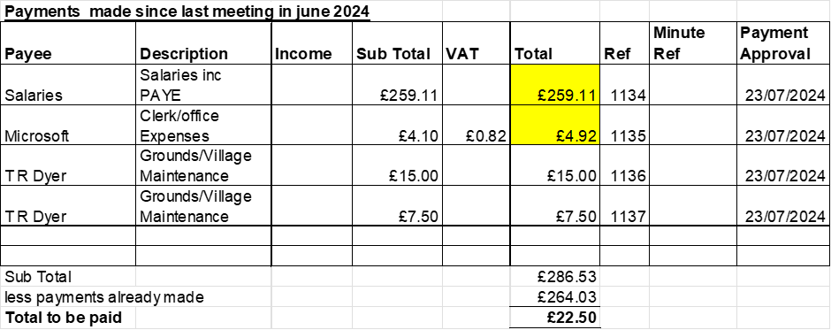  - To receive and approve monthly budget summary - APPROVED  - To receive and approve monthly bank reconciliation - APPROVED
12 | Councillor Information and items for the next Agenda.  - Roebuck pub has been removed from sale, no further information  - Suggest putting an article in the parish magazine, asking for future project ideas that are not highways related. Clerk to action.  Cllr Davies advised the following:  - Civic Sunday event  - Classic cars event in Stone Town  Cllr M O’Donoghue resigned from the parish council with immediate effect, he has now moved out of the area. He thanked everyone for making him feel welcome and has learned some interesting facts. Clerk to action casual vacancy on receipt of his resignation letter from the chairman.
13 | To agree a date for the next meeting  - 24th September 2024 at Hilderstone Village Hall
14 | Meeting Closed 20:52

