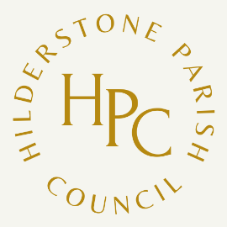

**Hilderstone Annual Parish Meeting**

to be held at

**Hilderstone Village Hall on**

**Tuesday 28th May 2024 at 7pm**

Under the Chairmanship of Councillor Jim Davies

Agenda

1 Chairman’s Welcome

2 Apologies

3 Approve previous minutes

4 Chairman’s Report

5 Borough Councillor’s Report

6 County Councillors Report

7 Public Participation

Cllr. J Davies

Chairman of the Parish Council

May 2024