Finance report 28.11.2023
Item 14 To approve monthly finances:
- To approve items for payment

- To receive and approve monthly budget summary – page 2
- To receive and approve monthly bank reconciliation – page 3
- To discuss and approve final budget for 2024/25 – page 4
- To approve salary, increase, backdated from 1st April 2023 - £1 increase across all SCP scales. Back pay to be paid to clerk in Decembers wage.

Bank reconciliation as at 10:45am 27.11.23

Balance as per statement £29,741.91

Less payments still to be made £540.52

Total as per cashbook £29,201.39

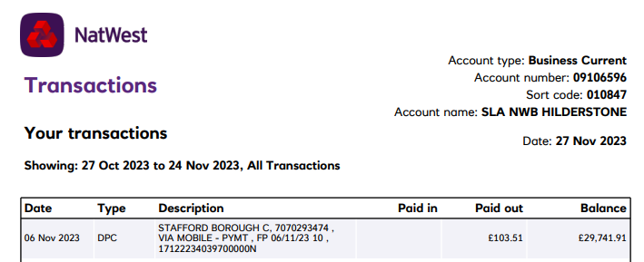
Signed ______________________________

Date ________________________________

Signed ______________________________

Date ________________________________

