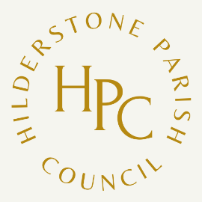
Hilderstone Annual Parish Meeting

to be held at
Hilderstone Village Hall on
Wednesday 24th May 2023 at 7pm

Under the Chairmanship of Councillor Jim Davies

The Parish Meeting may, by law, discuss all parish affairs and pass resolutions about them.

1 Chairman’s Welcome
2 Apologies
3 Chairman’s Report
4 Borough Councillor’s Report
5 County Councillors Report
6 Public Participation
Cllr. J Davies
Chairman of the Parish Council
May 2023

