Hilderstone Parish Council Meeting
‘

On Wednesday 23rd November at 7.30pm

This meeting was held at Hilderstone Village Hall, Sandon Rd, Hilderstone, Stone ST15 8SF

Attendance:
Cllr J Davies (Chairman) Cllr A Stringer (Vice Chairman) Cllr H Woodward Cllr R Clark Cllr M Shelley Cllr J Crump Nikola Evans – Clerk

Minutes
Item No. | Agenda Item
1 | To consider accepting apologies for absence and any reasons to be recorded.  Cllr P Davies – Accepted, Cllr A Harp – other commitments
2 | To approve the minutes of the last meeting held on 26th October 2022  Accepted as a true record by all that attended
3 | To record declarations of interest from members in any item to be discussed  None received
4 | To adjourn the meeting to allow public participation – Adjourned at 7.35pm
5 | To receive an update from the local PCSO – None attended
6 | To receive an update from the Borough Councillor – None
7 | To receive an update from the County Councillor - None
8 | To close the meeting to the public and continue with parish council business  Resumed at 7.40pm
9 | To discuss planning applications received – None received
10 | To discuss Stafford Borough Council Local Plan 2020-2040 - Stafford borough is consulting on their new Local Plan 2020-2040 from Monday 24  October 2022 until 12 noon on Monday 12 December 2022.  Concerns raised for the Meecebrook Garden Community, increase in traffic and environmental destruction. Consideration for nominating the space by the park area, off the Meadows by Brampton Croft and Roebuck as a designated green space.
11 | To consider the Boundary Commission for England's Revised Proposals in its final public  consultation which runs from Tuesday 8 November to Monday 5 December 2022.  Nothing for Hilderstone to be concerned about, predominantly concentrating on the merge of Great Wyrley with Stone.
12 | To review previously reported village issues on the clerk’s report.  Item Date Action  Severn Trent and Cotwalton Junction to B5066 ref: 4181743 & 4237100 - Missing bollards. 25.05.22 – still chasing 18.12.20 Monitor  Hedge cutting – Farm Lea, letters have been sent to all the residents 25.05.22 – still chasing 02.02.21 Monitor  Hedge cutting – 2 Farm Lea, pictures have been taken and sent to Stafford Rural Homes to investigate. – Chased with Stafford rural homes on 29.09.21 - no update yet. – clerk to chase – 29.10.21 – chased again – Clerk to forward information to Cllr J Davies to see if he may be able to push them as well. – Information has been passed to Cllr J Davies. – Cllr Davies has emailed. – 23.03.22 no further information has been received. Cllr J Davis will chase. – 27.04.22 – Cllr J Davies still chasing. 25.05.22 – still chasing – 22.06.22 – this issue has now been passed to Stafford Rural Homes Legal department to advise. – 20.07.22, advised by Homes Plus the footpath and hedge is outside the property boundary and therefore not the property owners’ responsibility. Clerk to report to Stafford County Council to trim back the hedges. 28.09.2022 Homes plus reported it’s not their responsibility, CC reported it’s not their responsibility. Next step to contact Accord Housing – Cllr PD will supply clerk with contact details. – 23.11.22 Clerk to request TGM to issue a quote to cut this section. 02.02.21 Monitor  White lines – Cotwalton Junction to B5066 23.02.22 – Clerk to report again, reporting a serious RTA which took place during December 2021 caused by drivers not keeping to the right side of the road. Clerk to extend from Spotgate to Junction B5066. Reported 23.03.22 – No further information has been received 25.05.22 – still chasing – 28.09.2022 – still to be resolved – RESOLVED October 2022 21.07.21 RESOLVED  Hedges – Hill Farm house and The Old Byer. Letter sent to both properties requesting the hedge cut back to the original boundary. 23.03.22 – Report to highways, they are now obstructing the road. – 27.04.22 Clerk to send a letter advising the owners legal responsibility. 15.05.22 – The hedge has now been cut back to the original boundary – 25.05.22, location has now been established and the clerk will send a letter to the residents. 22.09.21 Monitor  Severn Trent Gate Still has not been replaced – Cllr Woodward will see if she can obtain a contact from her source – clerk to write a letter – Severn Trent have been advised. – No further information has been received. 25.05.22 job number for Seven Trent to repair the gateway, 2005645554 Monitor  Erosion of bank opposite church buildout Clerk has reported to highways, believed due to wide vehicles using the road churning up the curb side. Children are having to walk in it, and it could potentially block the drains. 23.03.22 – No further information has been received. 23.02.22 Monitor  Road sign by Roebuck, this has been reported ref number - 4281637 13.05.22 Monitor  30mph road sign on Creswell Road by new SID’s – this has been reported, ref number - 4281636 13.05.22 Monitor  Footpath 14, report to SCC – ROW ref: 220730332 20.07.22 Monitor  Missing bollard – Road narrowing site by Roebuck Pub – ref 4288799 Someone has stuck the two bollards together, obstructing the hi vis section on the bollard. Clerk to report. 20.07.22 Monitor  Drain – Dingle Lane – original works reference 4288044 26.10.22 Monitor  Water spring, by buildout on Roebuck Bank. Concern has been raised, when temperature drops this will cause ice on the roads causing danger to vehicles. Needs reporting before anything happens. – ref 4298332 26.10.22 Monitor  Missing road sign, approaching Hilderstone crossroads from the village – ref 4291120 08.2022 Monitor  Broken kerb & footpath on Roebuck Hill. - 4299610 17.11.22 Monitor  Dingle Lane junction – Drain is sunken and dangerous clerk to report 23.11.22 Clerk  Play area, wetpour has shrunk and is now causing trip hazard, clerk to report to Stafford Borough Council. 23.11.22 Clerk
13 | To discuss any new traffic and highways issues.  None reported
14 | To discuss any new footpath and village Maintenance issues.  - Request buildout by the church needs clearing up before the frost. Clerk to request TGM  - Poo bin opposite bungalows on Dingle Lane, needs repositioning, clerk to report  - Roads through Hilderstone, Roebuck Bank and the Meadows need gritting. Clerk to request grit bins be refilled.
15 | To discuss employing a village handyman  Advertise in the new year
16 | To note upcoming village Events  - Arts & Craft Market – 26th November 2022  - Pop-up Pub – Mexican Night – 26th November 2022  - Christmas Tree Festival – 10-11th December 2022  - Christmas Panto & Concert – 17th December 2022
17 | To approve monthly finance – RFO  - To approve items for payment – approved  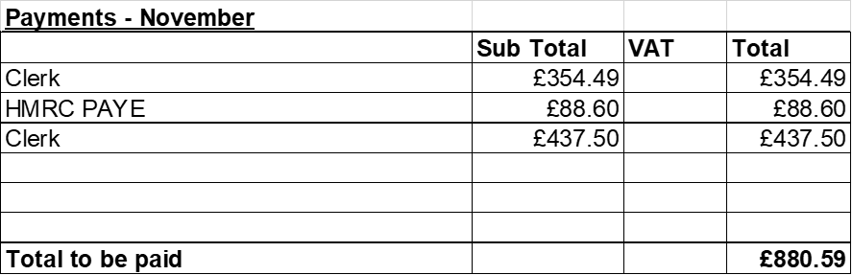  - To receive and approve monthly budget summary – circulated and approved  - To receive and approve monthly bank reconciliation – circulated and approved  - To approve budget for 2023-24 – circulated and approved, request precept of £12,455.
18 | Councillor Information and items for the next Agenda.  Cllr J Davies reported on the following:  - Stone theatre is hopefully reopening midsummer 2023  - Heritage centre hopefully reopening midsummer 2023  - Crown Wharf has been given a curfew  Cllr Davies expressed thanks on behalf of the parish council for Cllr R Clarks continued support over the years.
19 | To agree a date for the next meeting – 25th January 2023
20 | Meeting Closed – closed meeting at 8.50pm

