Item 14 Finance
- To approve items for payment

- To receive and approve monthly budget summary – page 2
- To receive and approve monthly bank reconciliation – page 3

Balance as at 22nd March 2023, as per statement £22,431.28

Less payments still to be made £608.41

Balance as per cashbook £21,822.87

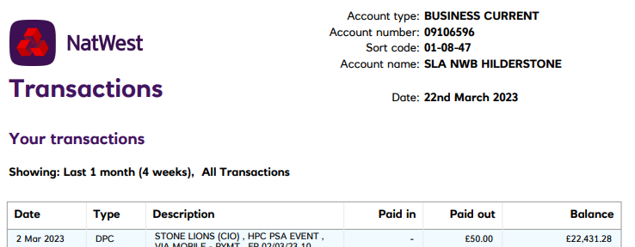

Signed ____________________ Date _____________________

Signed ____________________ Date _____________________

