Hilderstone Parish Council Meeting
‘

On Wednesday 25th January 2023 at 7.30pm

This meeting was held at Hilderstone Village Hall, Sandon Rd, Hilderstone, Stone ST15 8SF

Attendance:
Cllr J Davies (Chairman) Cllr A Stringer (Vice Chairman) Cllr M Shelley Cllr P Davies

Minutes
Item No. | Agenda Item
1 | To consider accepting apologies for absence and any reasons to be recorded.  Cllrs Jenny Crump and Hazel Woodward, and Nikola Evans (Clerk). The Chairman would take notes to be passed to the Clerk after the meeting for the production of the minutes.
2 | To approve the minutes of the last meeting held on 23rd November 2022  Approved as a true record by all that attended.
3 | To record declarations of interest from members in any item to be discussed  None received
4 | To adjourn the meeting to allow public participation  On behalf of the Parish Council Cllr Jim Davies, Chaiman, welcomed Mr Roy Clark and presented him with a gift of 2 rose bushes to mark his recent retirement as a councillor and to thank him for his 30 years’ service to the Council. Mrs Christine Clark was also welcomed.
5 | To receive an update from the local PCSO  None present
6 | To receive an update from the Borough Councillor  None Present
7 | To receive an update from the County Councillor  None present
8 | To close the meeting to the public and continue with parish council business  The chairman closed the meeting to the public
9 | To discuss planning applications received  - 23/36961/TCA – Rochford Cottage and Priory Cottage, Church Down, Hilderstone – Reduction of 7 x trees by 5m  The Council fully supported the application and noted that there was evidence that similar height reductions to these trees had been made successfully in the past. – No objections recorded.
10 | To review previously reported village issues on the clerk’s report.  Updates to the Clerk’s Report were agreed and the Chairman would send a copy of the updated report, highlighting areas that needed hastening, to the County Councillor for his attention.  There was uncertainty regarding:  - Whether 2 items, each regarding a drain in Dingle Lane, were one and the same problem; the Clerk would be asked to clarify.  - Exactly where responsibility lay regarding the hedges on the northbound side of the B5066 by Hill House Farm and The Old Byer; was it with the owners or with Highways? The Clerk would be asked to try to obtain clarification.  - ROW ref 220730332: Cllr Phil Davies would investigate.
11 | To discuss any new traffic and highways issues.  Cllr Philip Davies reported that flooding was occurring at the dip in Dingle Lane near to the bungalows and causing a hazard in icy conditions.
12 | To discuss any new footpath and village Maintenance issues.  None
13 | To discuss items for spring edition of parish magazine, deadline 20th February 2023  - Advertisement for village handyman  The Clerk would be asked to arrange for the following to be included:  - Advertisement for village handyman  - A suitable preliminary notification of the forthcoming election on Thursday 4 May 2023.
14 | To note upcoming village Events  - King Charles coronation  - It was agreed that the Council would not itself arrange an event to celebrate the forthcoming Coronation but would be happy to support suitable events in the Parish. It was further agreed that the Council would mark the event by planting a tree near the other commemorative trees in the play area. The Clerk would be asked to obtain a suitable tree and arrange for it to be planted as soon as possible. A simple ceremony would be held at around the date of the Coronation for the tree to be officially dedicated.  - The editor of the Parish Newsletter had sent out a list of future village events. Cllr Philip Davies would ask her to copy it to members of the Council who had not yet received it
15 | To approve monthly finance – RFO  - To approve items for payment  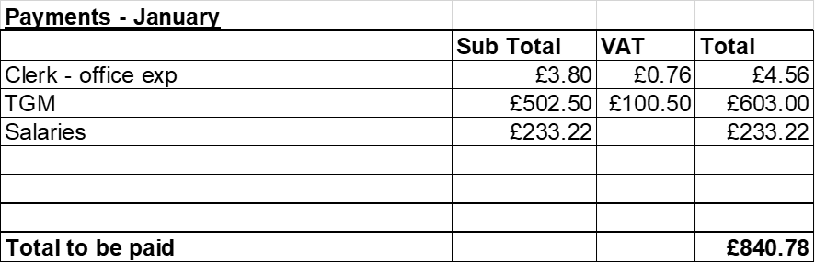  - To receive and approve monthly budget summary – circulated and approved  - To receive and approve monthly bank reconciliation – circulated and approved, The Clerk would be asked to clarify the figure of -812.00 shown as the difference regarding Precept Income.
16 | Councillor Information and items for the next Agenda.  - Cllr Jim Davies gave a verbal report of that afternoon’s meeting of the Stone Area Parish Liaison Group which, in addition to himself, had been attended by representatives of Stone Town, Stone Rural, Fulford, Barlaston, Yarnfield and Chebsey. The approved notes of the previous meeting (26 October 2022) would be circulated.  - Stone Town Council would be organising a street party on Sunday 7 May 2023 to celebrate the Coronation which would have taken place the day before. All would be welcome.
17 | To agree a date for the next meeting – 22nd February 2023 - Agreed
18 | Meeting Closed – closed at 8.36pm

