Hilderstone Parish Council Meeting
‘

On Wednesday 28th September at 7.30pm

This meeting was held at Hilderstone Village Hall, Sandon Rd, Hilderstone, Stone ST15 8SF

Attendance:
Cllr J Davies (Chairman) Cllr A Stringer (Vice Chairman) Cllr P Davies Cllr R Clark Cllr M Shelley Cllr H Woodward Cllr J Crump Nikola Evans – Clerk

Minutes
Item No. | Agenda Item
1 | To consider accepting apologies for absence and any reasons to be recorded. - None
2 | To approve the minutes of the last meeting held on 14th July 2022  Approved as a true record by all that attended
3 | To record declarations of interest from members in any item to be discussed - None
4 | To adjourn the meeting to allow public participation – Meeting was adjourned by the chairman at 19.40pm
5 | To receive an update from the local PCSO - None
6 | To receive an update from the Borough Councillor - None
7 | To receive an update from the County Councillor - None
8 | To close the meeting to the public and continue with parish council business – Meeting was resumed by the chairman at 19.45pm
9 | To discuss planning applications received - None
10 | To review previously reported village issues on the clerk’s report.  Item Date Action  Severn Trent and Cotwalton Junction to B5066 ref: 4181743 & 4237100 - Missing bollards. 25.05.22 – still chasing 18.12.20 Monitor  Hedge cutting – Farm Lea, letters have been sent to all the residents 25.05.22 – still chasing 02.02.21 Monitor  Hedge cutting – 2 Farm Lea, pictures have been taken and sent to Stafford Rural Homes to investigate. – Chased with Stafford rural homes on 29.09.21 - no update yet. – clerk to chase – 29.10.21 – chased again – Clerk to forward information to Cllr J Davies to see if he may be able to push them as well. – Information has been passed to Cllr J Davies. – Cllr Davies has emailed. – 23.03.22 no further information has been received. Cllr J Davis will chase. – 27.04.22 – Cllr J Davies still chasing. 25.05.22 – still chasing – 22.06.22 – this issue has now been passed to Stafford Rural Homes Legal department to advise. – 20.07.22, advised by Homes Plus the footpath and hedge is outside the property boundary and therefore not the property owners’ responsibility. Clerk to report to Stafford County Council to trim back the hedges. 28.09.2022 Homes plus reported its not their responsibility, CC reported its not their responsibility. Next step to contact Accord Housing – Cllr PD will supply clerk with contact details. 02.02.21 Monitor  White lines – Cotwalton Junction to B5066 – 4251576 – No further updates - Updated 7.02.22 from Highways - We have not yet been able to coordinate resources to resolve the enquiry you raised, due to high demand for reactive maintenance work across our road network. We write to assure you that we have not forgotten about the issue and will endeavour to schedule the necessary works as soon as is practicably possible. In the meantime, we will continue to monitor the issue by way of our routine safety inspections which take place monthly, quarterly, or annually depending on the road classification. If we identify that the problem has worsened, we may reprioritise the repair works accordingly, alternatively if you believe the defect now poses an imminent risk to safety, we would kindly ask that you report the issue again via: www.staffordshire.gov.uk/report it. RESOLVED 23.02.22 – Clerk to report again, reporting a serious RTA which took place during December 2021 caused by drivers not keeping to the right side of the road. Clerk to extend from Spotgate to Junction B5066. Reported 23.03.22 – No further information has been received 25.05.22 – still chasing – 28.09.2022 – still to be resolved 21.07.21 Part Resolved  Hedges – Hill Farm house and The Old Byer. Letter sent to both properties requesting the hedge cut back to the original boundary. 23.03.22 – Report to highways, they are now obstructing the road. – 27.04.22 Clerk to send a letter advising the owners legal responsibility. 15.05.22 – The hedge has now been cut back to the original boundary – 25.05.22, location has now been established and the clerk will send a letter to the residents. 22.09.21 Clerk  Severn Trent Gate Still has not been replaced – Cllr Woodward will see if she can obtain a contact from her source – clerk to write a letter – Severn Trent have been advised. – No further information has been received. 25.05.22 job number for Seven Trent to repair the gateway, 2005645554 Monitor  Erosion of bank opposite church buildout Clerk has reported to highways, believed due to wide vehicles using the road churning up the curb side. Children are having to walk in it, and it could potentially block the drains. 23.03.22 – No further information has been received. 23.02.22 Monitor  Road sign by Roebuck, this has been reported ref number - 4281637 13.05.22 Monitor  30mph road sign on Creswell Road by new SID’s – this has been reported, ref number - 4281636 13.05.22 Monitor  Discarded road maintenance signs need to be collected – clerk to email highways. RESOLVED 25.05.22 RESOLVED  Footpath 14, report to SCC – ROW ref: 220730332 20.07.22  1 Farm Lea – Overgrown, rubbish and burning something in grounds that is not normal garden waste. – Reported to Homes Plus 20.07.22  Missing bollard – Road narrowing site by Roebuck Pub – ref 4288799 20.07.22
11 | To discuss any new traffic and highways issues.  - Reports of tractors speeding through village and using mobile phones. Clerk to write to NFU, Stone & Cheadle Office – Danny Mulligan and highways.
12 | To discuss any new footpath and village Maintenance issues.  - Reported large combine harvester has entered Dingle Lane and caused damage to the verge and knocked over the dog waste bin. – No action required.  - Advertise maintenance for the planters in the next parish magazine. Cllr Roy Clerk will write an article.
13 | To note upcoming village Events  - Elvis – 8th October 2022  - Harvest supper 9/10th October 2022
14 | To approve monthly finance – RFO  - To approve items for payment – circulated and approved  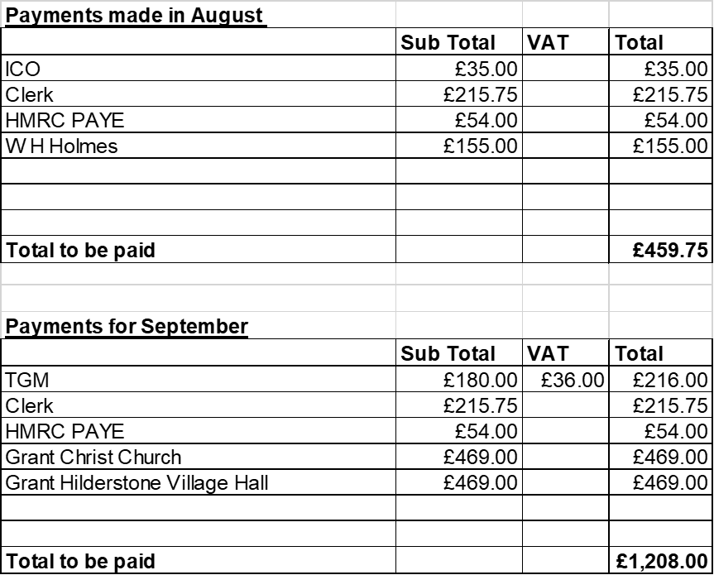  Also approved £21.99 expenses for Cllr J Crump and clerk to sign up to subscription to OneDrive for data storage @ £3.80 + VAT per month.  - To receive and approve monthly budget summary – Circulated and approved  - To receive and approve monthly bank reconciliation – Circulated and approved
15 | To discuss and approve quotation from Mr B Shelley for a new noticeboard.  Approved @ £350 – Cllr A Stringer to advise Mr Shelley to continue, clerk to speak with Hilderstone Village Hall regarding paying half towards the cost.
16 | To receive and adopt reviewed and new policies  - Equality and Diversity Policy – circulated and approved  - Homeworking Policy – circulated and approved  - Lone working Policy – circulated and approved  - Standing Orders Sept 2022 – circulated and approved  - Financial Regulations Sept 2022 – circulated and approved  All policies can be found on our website https://hilderstone.org.uk/
17 | To discuss and approve taking the pledge for Civility and Respect.  The parish council agreed to take the civility and respect pledge, information can be found on our website. https://hilderstone.org.uk/ clerk to submit.
18 | Councillor Information and items for the next Agenda. - None
19 | To agree a date for the next meeting – 26th October 2022
20 | Meeting Closed – The chairman closed the meeting at 20.55pm

