**RFO – Finance report – 28th September 2022 – Item 14**

1. To approve items for payment



1. To receive and approve monthly budget summary – page 2
2. To receive and approve monthly bank reconciliation – page 3



**Bank reconciliation as at 20th September 2022**

Balance as per statement £19,723.75

Less payments £1,208

Balance as per cash book £18,300.00



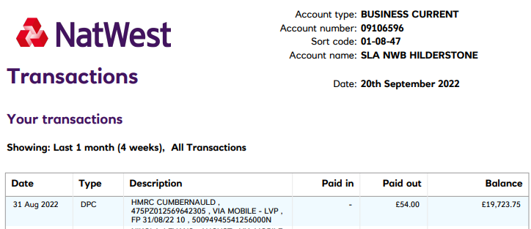

Signed ­­­­­­­­­­­_____________________ Date _________________

Signed _____________________ Date _________________