Hilderstone Annual Parish Council Meeting
‘

On Wednesday 25th May 2022 at 7.30pm

This meeting was held at Hilderstone Village Hall, Sandon Rd, Hilderstone, Stone ST15 8XF

Attendance:
Cllr J Davies (Chairman) Cllr A Stringer (Vice Chairman) Cllr R Clark Cllr J Crump Cllr H Woodward
Nikola Evans – Clerk

Minutes

1 | Election of Chairman – Proposed Cllr J Davies and accepted
2 | Election of Vice Chairman – Proposed Cllr A Stringer and accepted
3 | Apologies – Cllr M Shelley, Cllr P Davies and Cllr A Harp were unable to attend due to other commitments - accepted
4 | Minutes of the last meetings – 27th April 2022 – Approved as a true record of events by all that attended.
5 | Declaration of Interests on agenda items - None
6 | Local PCSO update - None
7 | Public Participation - None
8 | Borough Councillor’s Report - None
9 | County Councillor’s Report - None
10 | Planning - None
11 | Clerks Report  Item Date Action  Severn Trent and Cotwalton Junction to B5066 ref: 4181743 & 4237100 - Missing bollards. 25.05.22 – still chasing 18.12.20 Monitor  Hedge cutting – Farm Lea, letters have been sent to all the residents 25.05.22 – still chasing 02.02.21 Monitor  Hedge cutting – 2 Farm Lea, pictures have been taken and sent to Stafford Rural Homes to investigate. – Chased with Stafford rural homes on 29.09.21 - no update yet. – clerk to chase – 29.10.21 – chased again – Clerk to forward information to Cllr J Davies to see if he may be able to push them as well. – Information has been passed to Cllr J Davies. – Cllr Davies has emailed. – 23.03.22 no further information has been received. Cllr J Davis will chase. – 27.04.22 – Cllr J Davies still chasing. 25.05.22 – still chasing 02.02.21 Monitor  White lines – Cotwalton Junction to B5066 – 4251576 – No further updates - Updated 7.02.22 from Highways - We have not yet been able to coordinate resources to resolve the enquiry you raised, due to high demand for reactive maintenance work across our road network. We write to assure you that we have not forgotten about the issue and will endeavour to schedule the necessary works as soon as is practicably possible. In the meantime, we will continue to monitor the issue by way of our routine safety inspections which take place monthly, quarterly, or annually depending on the road classification. If we identify that the problem has worsened, we may reprioritise the repair works accordingly, alternatively if you believe the defect now poses an imminent risk to safety, we would kindly ask that you report the issue again via: www.staffordshire.gov.uk/report it. 23.02.22 – Clerk to report again, reporting a serious RTA which took place during December 2021 caused by drivers not keeping to the right side of the road. Clerk to extend from Spotgate to Junction B5066. Reported 23.03.22 – No further information has been received 25.05.22 – still chasing 21.07.21 Monitor  Hedges – Hill Farm house and The Old Byer. Letter sent to both properties requesting the hedge cut back to the original boundary. 23.03.22 – Report to highways, they are now obstructing the road. – 27.04.22 Clerk to send a letter advising the owners legal responsibility. 15.05.22 – The hedge has now been cut back to the original boundary – 25.05.22, location has now been established and the clerk will send a letter to the residents. 22.09.21 Clerk  Severn Trent Gate Still has not been replaced – Cllr Woodward will see if she can obtain a contact from her source – clerk to write a letter – Severn Trent have been advised. – No further information has been received. 25.05.22 job number for Seven Trent to repair the gateway, 2005645554 Monitor  Lower Farm, Sandon Road/Creswell Road. – Listed building is deteriorating. 26.01.22 Monitor  Erosion of bank opposite church buildout Clerk has reported to highways, believed due to wide vehicles using the road churning up the curb side. Children are having to walk in it, and it could potentially block the drains. 23.03.22 – No further information has been received. 23.02.22 Monitor  Road sign by Roebuck, this has been reported ref number - 4281637 13.05.22 Monitor  30mph road sign on Creswell Road by new SID’s – this has been reported, ref number - 4281636 13.05.22 Monitor  Discarded road maintenance signs need to be collected – clerk to email highways. 25.05.22 Monitor
12 | Traffic and Highways  - To discuss HS2  Advised by Cllr I Parry - The area around Hilderstone level is not in the current minerals plan. If HS2 or the owner wanted to extract material they would need to apply to the County Council. They have not, so it would seem that there is no plan to do so.
13 | Footpaths, Village Maintenance  - To discuss maintenance of churchyard trees  The parish council have agreed to look at helping financially when the Church applies.  - To discuss installing new bin in the layby.  The parish council have rejected the suggestion of a new bin in the layby. They feel it would encourage more litter.
14 | Village Events  - 4 June 2022 - Beyond the Barricade  - 22nd July 2022 - Gordon Giltrap
15 | Finance – RFO  - Monthly payment approval – approved for payment  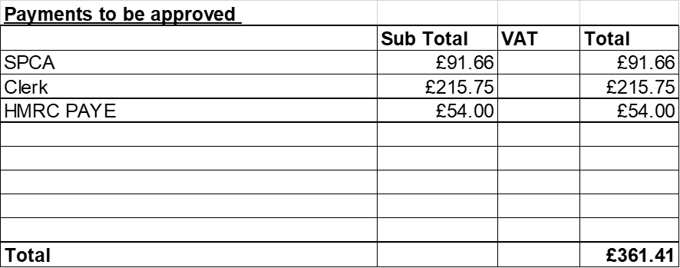  - Budget summary – circulated and approved  - Bank reconciliation – circulated and approved
16 | Councillor Information and items for the next Agenda  Cllr J Davies reported on the following:  - School transport - ongoing problem regarding the use of school buses by pupils over the age of 16 and the following statement has just been passed by Eccleshall council. Suggest the parish council to do the same. Clerk to send letter. “This council notes the Government allows a delay to the implementation of PSVAR regulations for home-to-school transportation and will write to the County Council to ask that this exemption be requested for all routes in our parish where a student seeks to travel to school, is currently barred from doing so through County Council policy, and yet lives more than two miles from a public transport option. This would allow the County Council to charge the student a reasonable fee for the use of any spare (used) seats if available, until such a time as the vehicle is replaced with one that is PSVAR-compliant or the government exemption expires."  - Commonwealth games trophy to be taken through Stone on 19th July 2022  - Mayor making service, very nice event.
17 | To agree date of next meeting – 22nd June 2022 from 7.30pm
18 | Meeting Closed – meeting closed at 8.30pm

