Hilderstone Parish Council Meeting
‘

On Wednesday 27th April 2022 at 7.30pm

This meeting was held at Hilderstone Village Hall, Sandon Rd, Hilderstone, Stone ST15 8XS

Attendance:
Cllr J Davies (Chairman) Cllr A Stringer (Vice Chairman) Cllr P Davies Cllr R Clark Cllr J Crump Cllr M Shelley Cllr H Woodward
Cllr A Harp SBC Nikola Evans – Clerk

Minutes
1 | Chairman’s Welcome
2 | Apologies - None
3 | Minutes of the last meetings – 23rd March 2022 – Approved as a true record of the meeting by all that attended.
4 | Declaration of Interests on agenda items - None
5 | Local PCSO update - None
6 | Public Participation - None
7 | Borough Councillor’s Report – See attached report
8 | County Councillor’s Report - None
9 | Planning - None
10 | Clerks Report  Item Date Action  Severn Trent and Cotwalton Junction to B5066 ref: 4181743 & 4237100 Missing bollards. 18.12.20 Monitor  SIDS – Awaiting installation – now installed - RESOLVED 26.01.21 Clerk  Queens 70th anniversary – Plaque still to be arranged. Possible suggestion for a “tea and cake” event closer to July. Cllr R Clerk will provide a photo and dimensions. – RESOLVED – clerk to purchase 2 x plaques from Brunel Engraving @ £67.85 + VAT 26.05.21 RESOLVED  Hedge cutting – Farm Lea, letters have been sent to all the residents 02.02.21 Monitor  Hedge cutting – 2 Farm Lea, pictures have been taken and sent to Stafford Rural Homes to investigate. – Chased with Stafford rural homes on 29.09.21 - no update yet. – clerk to chase – 29.10.21 – chased again – Clerk to forward information to Cllr J Davies to see if he may be able to push them as well. – Information has been passed to Cllr J Davies. – Cllr Davies has emailed. – 23.03.22 no further information has been received. Cllr J Davis will chase. – 27.04.22 – Cllr J Davies still chasing. 02.02.21 Monitor  White lines – Cotwalton Junction to B5066 – 4251576 – No further updates - Updated 7.02.22 from Highways - We have not yet been able to coordinate resources to resolve the enquiry you raised, due to high demand for reactive maintenance work across our road network. We write to assure you that we have not forgotten about the issue and will endeavour to schedule the necessary works as soon as is practicably possible. In the meantime, we will continue to monitor the issue by way of our routine safety inspections which take place monthly, quarterly, or annually depending on the road classification. If we identify that the problem has worsened, we may reprioritise the repair works accordingly, alternatively if you believe the defect now poses an imminent risk to safety, we would kindly ask that you report the issue again via: www.staffordshire.gov.uk/report it. 23.02.22 – Clerk to report again, reporting a serious RTA which took place during December 2021 caused by drivers not keeping to the right side of the road. Clerk to extend from Spotgate to Junction B5066. Reported 23.03.22 – No further information has been received 21.07.21 Monitor  Hedges – Hill Farm house and The Old Byer. Letter sent to both properties requesting the hedge cut back to the original boundary. 23.03.22 – Report to highways, they are now obstructing the road. – 27.04.22 Clerk to send a letter advising the owners legal responsibility. 22.09.21 Clerk  Severn Trent Gate Still has not been replaced – Cllr Woodward will see if she can obtain a contact from her source – clerk to write a letter – Severn Trent have been advised. – No further information has been received. Monitor  Lower Farm, Sandon Road/Creswell Road. – Listed building is deteriorating. 26.01.22 Monitor  Erosion of bank opposite church buildout Clerk has reported to highways, believed due to wide vehicles using the road churning up the curb side. Children are having to walk in it, and it could potentially block the drains. 23.03.22 – No further information has been received. 23.02.22 Monitor
11 | Traffic and Highways  - 30mph sign on Creswell Road just before the new SID’s – Clerk to report  - Roebuck Bank, Sandon Road. Road narrowing sign is falling off and needs securing. – Clerk to report.
12 | Footpaths, Village Maintenance  TGM have been contacted and will carry out the following:  - Village Green  - Play area’s flower box  - Footpath 14, between houses  - Cotwalton Corner  - General maintenance at the play area.
13 | Village Events  - Clerk to invite Bill and Ann Holmes to the Annual public meeting.
14 | Finance – RFO  - Monthly payment approval – approved  Clerk deferred office exp to next month’s meeting.  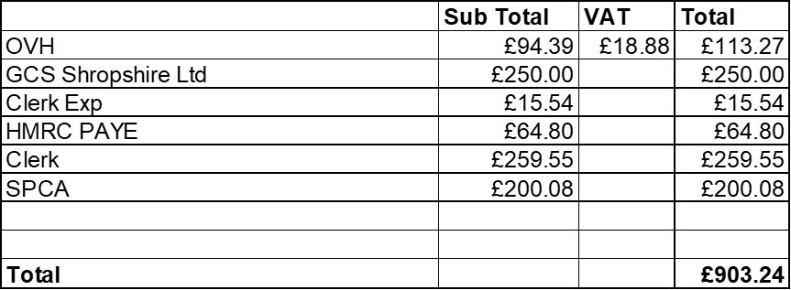  - Budget summary – circulated and approved  - Bank reconciliation – circulated and approved  - End of year bank reconciliation 2021/22 – circulated and approved  Approved £149.99 to Mr TC Woodward out of section 137 budget.
15 | To approve Grievance policy – adopted and approved
16 | To approve Complaints Procedures for Hilderstone Parish Council – adopted and approved
17 | To approve HPC Information Data Protection Policy – adopted and approved
18 | Councillor Information and items for the next Agenda  Cllr J Davies provided an update from the Stone area parish liaison group.  Items for next meeting  - To discuss HS2  - Churchyard tree’s
19 | To agree date of next meeting – 25th May 2022  - Annual Public meeting from 7pm to 7.30pm  - Annual Parish Council meeting from 7.30 to 9pm
20 | Meeting Closed – The chairman thanked everyone or attending and closed the meeting at 20.45pm

