Hilderstone Parish Council Meeting
‘

On Wednesday 23rd March 2022 at 7.30pm

This meeting was held at Hilderstone Village Hall, Sandon Rd, Hilderstone, Stone ST15 8XS

Attendance:
Cllr J Davies (Chairman) Cllr A Stringer (Vice Chairman) Cllr P Davies Cllr R Clark Cllr J Crump Cllr M Shelley Cllr H Woodward
Cllr A Harp SBC Nikola Evans – Clerk

Minutes
1 | Chairman’s Welcome
2 | Apologies - None
3 | Minutes of the last meetings – 23rd February 2022 – Approved and accepted as a true record of the meeting by all that attended.
4 | Declaration of Interests on agenda items – Cllr P Davies, Cllr A Stringer and Cllr R Clark – Item 12a.
5 | Local PCSO update - None
6 | Public Participation - None
7 | Borough Councillor’s Report  Cllr A Harp presented the parish council with the monthly report – see attached.
8 | County Councillor’s Report - None
9 | Planning - None
10 | Clerks Report  Item Date Action  Severn Trent and Cotwalton Junction to B5066 ref: 4181743 & 4237100 Missing bollards. 18.12.20 Monitor  SIDS – Awaiting installation 26.01.21 Clerk  Queens 70th anniversary – Plaque still to be arranged. Possible suggestion for a “tea and cake” event closer to July. Cllr R Clerk will provide a photo and dimensions. 26.05.21 Clerk PART RESOLVED  Hedge cutting – Farm Lea, letters have been sent to all the residents 02.02.21 Monitor  Hedge cutting – 2 Farm Lea, pictures have been taken and sent to Stafford Rural Homes to investigate. – Chased with Stafford rural homes on 29.09.21 - no update yet. – clerk to chase – 29.10.21 – chased again – Clerk to forward information to Cllr J Davies to see if he may be able to push them as well. – Information has been passed to Cllr J Davies. – Cllr Davies has emailed. – 23.03.22 no further information has been received. Cllr J Davis will chase. 02.02.21 Monitor  White lines – Cotwalton Junction to B5066 – 4251576 – No further updates - Updated 7.02.22 from Highways - We have not yet been able to coordinate resources to resolve the enquiry you raised, due to high demand for reactive maintenance work across our road network. We write to assure you that we have not forgotten about the issue and will endeavour to schedule the necessary works as soon as is practicably possible. In the meantime, we will continue to monitor the issue by way of our routine safety inspections which take place monthly, quarterly, or annually depending on the road classification. If we identify that the problem has worsened, we may reprioritise the repair works accordingly, alternatively if you believe the defect now poses an imminent risk to safety, we would kindly ask that you report the issue again via: www.staffordshire.gov.uk/report it. 23.02.22 – Clerk to report again, reporting a serious RTA which took place during December 2021 caused by drivers not keeping to the right side of the road. Clerk to extend from Spotgate to Junction B5066. Reported 23.03.22 – No further information has been received 21.07.21 Monitor  Hedges – Hill Farm house and The Old Byer. Letter sent to both properties requesting the hedge cut back to the original boundary. 23.03.22 – Report to highways, they are now obstructing the road. 22.09.21 Clerk  Severn Trent Gate Still has not been replaced – Cllr Woodward will see if she can obtain a contact from her source – clerk to write a letter – Severn Trent have been advised. – No further information has been received. Monitor  Lower Farm, Sandon Road/Creswell Road. – Listed building is deteriorating. 26.01.22 Monitor  Erosion of bank opposite church buildout Clerk has reported to highways, believed due to wide vehicles using the road churning up the curb side. Children are having to walk in it, and it could potentially block the drains. 23.03.22 – No further information has been received. 23.02.22 Monitor
11 | Traffic and Highways
12 | Footpaths, Village Maintenance  - To discuss grant for church yard maintenance. – Carried forward from Item 12a at the meeting on 23.02.22. – Approved to donate £250 to contribute to church yard maintenance.  The following have been raised as a concern by a resident.  - Blocked drain at the end of Dingle Lane on B5066 – needs unblocking as otherwise will cause a safety hazard especially in cold weather – reported, ref number 4274914  - Sign going out of the village towards the crossroads has been hit and needs repairing – Reported, ref number 4274912  - A small tree has come down in the wind and is across the pathway near the alleyway leading onto the estate. – RESOLVED tree has been moved.  - New farm gateway, Dingle Lane Field. – RESOLVED the original gate which was damaged has been replaced by the landowners.
13 | Village Events  - Mother’s Day service 27th March 2022 – Hilderstone Christ Church  - Craft market, pop up pub and takeaway – 26th March 2022  - To discuss thank you to Bill Holmes – Clerk will investigate parish council funds and advise. Parish Council will decide on a gift.
14 | Finance – RFO  - Monthly payment approval  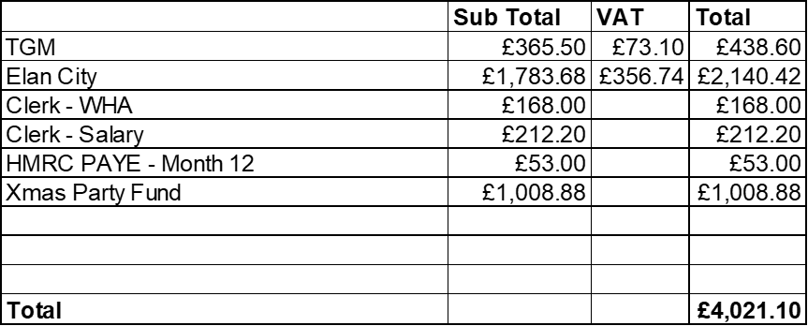  - Budget summary – circulated and approved  - Bank reconciliation – circulated and approved  - To approve national pay rise backdated from 01.04.2021 - £54.60 - approved  - To approve payment of £113.26 to OVH for VIN before next meeting on 27th April 2022 – approved to pay before the next meeting.
15 | Councillor Information and items for the next Agenda  The parish council would like to thank the volunteers for their efforts with making the village look nice for all to enjoy.
16 | To agree date of next meeting – 27th April 2022 from 7.30pm
17 | Meeting Closed – 20.20pm

