Hilderstone Parish Council Meeting
‘

On Wednesday 23rd February 2022 at 7.30pm

This meeting was held at Hilderstone Village Hall, Sandon Rd, Hilderstone, Stone ST15 8XS

Attendance:
Cllr J Davies (Chairman) Cllr A Stringer Cllr P Davies Cllr R Clark Cllr J Crump Nikola Evans – Clerk

Minutes

1 | Chairman’s Welcome
2 | Apologies – Cllr M Shelly, Cllr H Woodward and Cllr A Harp
3 | Minutes of the last meetings – 26th January 2022 – approved as a true record of events by all that attended.
4 | Declaration of Interests on agenda items – Cllr A Stringer, Cllr R Clark and Cllr P Davies – Item 12a
5 | Local PCSO update – No available
6 | Public Participation – None attended
7 | Borough Councillor’s Report – No available
8 | County Councillor’s Report – No available
9 | Planning - None
10 | Clerks Report  Item Date Action  Severn Trent and Cotwalton Junction to B5066 ref: 4181743 & 4237100 Missing bollards. 18.12.20 Monitor  SIDS - Now installed, next step is to move the original SID’s – possibly ask TGM if they would be able to help. – Resolved to obtain a quote to buy another device instead. Clerk to get quotes. 26.01.21 Clerk  Queens 70th anniversary – Approved to purchase to cherry trees and a plaque the same as the 60th anniversary. TGM will purchase trees. Cllr R Clark to provide dimensions of current plaque. Clerk to organise quotes. PART RESOLVED – two trees have been planted by TGM, plaque still to be arranged. Possible suggestion for a “tea and cake” event closer to July. 26.05.21 Clerk PART RESOLVED  Hedge cutting – Farm Lea, letters have been sent to all the residents 02.02.21 Monitor  Hedge cutting – 2 Farm Lea, pictures have been taken and sent to Stafford Rural Homes to investigate. – Chased with Stafford rural homes on 29.09.21 - no update yet. – clerk to chase – 29.10.21 – chased again – Clerk to forward information to Cllr J Davies to see if he may be able to push them as well. – Information has been passed to Cllr J Davies. 02.02.21 Monitor  Two trees cut down by contractors. Parish council agreed to pay for the replacement of the two trees at a cost of approx. £120 – TGM will replant – RESOLVED, two trees have been planted by TGM at a cost of £151 + VAT 27.10.21 RESOLVED  White lines – Cotwalton Junction to B5066 – 4251576 – No further updates - Updated 7.02.22 from Highways - We have not yet been able to coordinate resources to resolve the enquiry you raised, due to high demand for reactive maintenance work across our road network. We write to assure you that we have not forgotten about the issue and will endeavour to schedule the necessary works as soon as is practicably possible. In the meantime, we will continue to monitor the issue by way of our routine safety inspections which take place monthly, quarterly, or annually depending on the road classification. If we identify that the problem has worsened, we may reprioritise the repair works accordingly, alternatively if you believe the defect now poses an imminent risk to safety, we would kindly ask that you report the issue again via: www.staffordshire.gov.uk/report it. 23.02.22 – Clerk to report again, reporting a serious RTA which took place during December 2021 caused by drivers not keeping to the right side of the road. Clerk to extend from Spotgate to Junction B5066. 21.07.21 Clerk  Hedges – Hill Farm house and The Old Byer. Letter sent to both properties requesting the hedge cut back to the original boundary. 22.09.21 Monitor  Severn Trent Gate Still has not been replaced – Cllr Woodward will see if she can obtain a contact from her source – clerk to write a letter – Severn Trent have been advised. Monitor  Lower Farm, Sandon Road/Creswell Road. – Listed building is deteriorating. 26.01.22 Monitor
11 | Traffic and Highways  - To discuss and approve purchase of another SID’s unit.  Approved to order new SID’s unit at a cost of £1783.68 + vat, clerk to organise.  - Erosion of bank opposite church buildout.  Clerk to report to highways, believed due to wide vehicles using the road churning up the curb side. Children are having to walk in it and it could potentially block the drains.  Cllr J Davies reported on the road closure on Sandon Road. There was very little information provided to the parish council. Clerk has now signed up to One Network and is receiving local future temporary traffic regulation orders.
12 | Footpaths, Village Maintenance  - To discuss grant for church maintenance  Subject was discussed, however due to the parish council not being quorate on this item it was deferred to the next meeting in March.  - Footpath adjacent to Hawthorne children’s play area  overgrown. Cllr J Davies will investigate.
13 | Village Events  - Arts and Craft – Village Hall - 26.02.22  - Italian night – Village Hall – 26.02.22
14 | Correspondence - None
15 | Finance – RFO  - Monthly payment approval – Approved  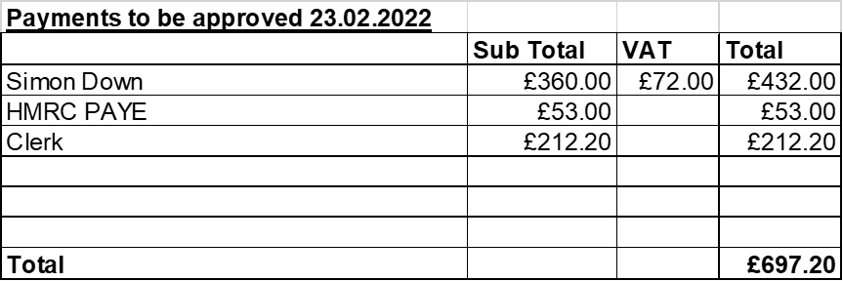  - Budget summary – circulated and approved  - Bank reconciliation – circulated and approved  - To approve clerks annual pay increase from £12 per hour to £12.24 – approved by all that was present, to take effect from 01.02.22
16 | Councillor Information and items for the next Agenda  - Church Grant  - Giving thanks to Bill Holmes for his work keeping the village tidy.
17 | To agree date of next meeting – 23rd March 2022 from 7.30pm
18 | Meeting Closed – Meeting closed at 8.28pm

