Hilderstone Parish Council Meeting
‘

On Wednesday 27th October 2021 at 7.30pm

This meeting was held at Hilderstone Village Hall, Sandon Rd, Hilderstone, Stone ST15 8XS

Attendance:
Cllr J Davies (Chairman) Cllr A Stringer (Vice Chairman) Cllr M Shelley
Cllr H Woodward Cllr J Crump Cllr P Davies Cllr R Clark Cllr A Harp - SBC Nikola Evans – Clerk

Minutes

1 | Chairman’s Welcome – Cllr J Davies welcomed everyone to the meeting
2 | Apologies - None
3 | Minutes of the last meetings – Approved as a true record of the meeting on 22nd September 2021
4 | Declaration of Interests on agenda items - None
5 | Local PCSO update  PCSO 23800 Emma Fry reported the following:  - 7 x Transport issues  - 1 x Theft  Within the local area of Hilderstone Parish.
6 | Public Participation - None
7 | Borough Councillor’s Report  Cllr A Harp reported on the following:  - Backlog of planning applications continues  - Fly tipping  - Stone’s waste disposal site
8 | County Councillor’s Report - None
9 | Planning  Cllr R Clark reported there is a planning application expected for No.12 Eastcote, dropped kerb.
10 | Clerks Report  Item Date Action  Severn Trent and Cotwalton Junction to B5066 ref: 4181743 & 4237100 Missing bollards. 18.12.20 Monitor  SIDS – Installation w/c 18.10.21 Still not installed – clerk to chase again 26.01.21 Clerk to Chase  Queens 70th anniversary – Approved to purchase to cherry trees and a plaque the same as the 60th anniversary. 26.05.21 Clerk in 2022  Hedge cutting – Farm Lea, letters have been sent to all the residents 02.02.21 Monitor  Hedge cutting – 2 Farm Lea, pictures have been taken and sent to Stafford Rural Homes to investigate. – Chased with Stafford rural homes on 29.09.21 - no update as yet. – clerk to chase 02.02.21 Clerk Chase and Monitor  Two trees cut down by contractors. Contract has been cancelled and works passed over to our new contractors TGM – Parish council agreed to pay for the replacement of the two trees at a cost of approx £120 – Cllr R Clark to speak with contractor. 27.10.21 Clerk & Cllr R Clark  Hilderstone Walkway / Trees Site has been identified – plot of land Dingle Lane – email received from Highways. “The area you have circled blue does appear to take in part of the highway maintainable at public expense. The area edged blue fronting property The Hollies does not form part of the highway maintainable at public expense and we do not hold information regarding ownership on third party land. It may be beneficial to obtain a highway extent search plan so you are able to clearly identify the limits of responsibility that Staffordshire County Council have in this vicinity.” There is a cost to obtain this, and I have emailed to ask them what it is. – Clerk to ivestigate 22.09.21 Clerk  White lines – Cotwalton Junction to B5066 – 4251576 – No further updates 21.07.21 Monitor  White lines – The Narrows – Roebuck to Chicane – 4255981 – update received from Amey – “A highways officer has now considered your enquiry and added the following notes to your report: We have inspected the location provided with your report and were not able to identify any defects posing a safety risk that require remedial works at this time. Although the area may show aesthetic signs of deterioration the County Council is not in a position to carry out works to address this. We will continue to monitor this site during routine safety inspections.” – Clerk advised case has been closed with no resolution from Highways. 23.09.21 Closed  Hedges – Hill Farm and The Old Byer. Letter sent to both properties requesting the hedge cut back to the original boundary. 22.09.21 Monitor
11 | Traffic and Highways - None
12 | Footpaths, Village Maintenance  - Dog Fouling  Parish council agreed to issue a reminder in the parish magazine – Clerk  Stiles on footpaths 4 & 9 have been reported to rights of way – still need fixing.  Footpath 12 – blockage has been removed  Stile needs repairing at Hawthornes – Cllr P Davies
13 | Village Events  18th December 2021 – Panto at Hilderstone Village Hall – Aladdin – times and prices to be advised. Future events can also be seen on the website and Hilderstone Village Hall website.
14 | Correspondence - None
15 | Finance – RFO  - Payment approval  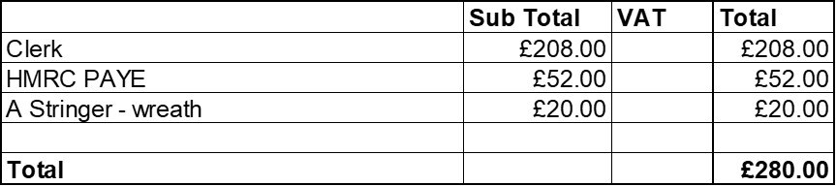  - Budget against performance - approved  - Bank reconciliation - approved  - Draft Budget 2022/23 – presented and will approve at the next meeting in November.
16 | Councillor Information and items for the next Agenda  Cllr J Davies reported on the following:  - Availability of Stafford Borough Council  - Planning application portal - unable to view  - Temporary vacant seat scheme – School Buses – still pursuing  Invite Hilderstone Village Hall Committee to next meeting.
17 | To agree date of next meeting – 24th November 2021 @ 7.30pm
18 | Meeting Closed  Cllr J Davies thanked everyone for attending and closed the meeting at 20.41pm

