Hilderstone Parish Council Meeting

On Wednesday 21st July 2021 at 7.30pm

This meeting was held at Hilderstone Village Hall, Sandon Rd, Hilderstone, Stone ST15 8XS

Attendance:
Cllr J Davies (Chairman) Cllr A Stringer (Vice Chairman) Cllr M Shelley
Cllr P Davies Cllr R Clark Cllr J Crump
Nikola Evans – Clerk

There were also three residents in attendance.

Minutes

1 | Chairman’s Welcome  Cllr J Davies welcomed everyone to the meeting and thanked the previous chairman for the last four years.
2 | Apologies  Cllr H Woodward – Accepted  Cllr A Harp - Isolating
3 | Minutes of the last meetings  Approved as a true record of events by all that attended.
4 | Declaration of Interests on agenda items  None
5 | Public Participation  The following points were raised by residents:  - Grass verges on Dingle Lane by the bungalows, need attending to – see item 11  - The alleyway by the children’s playground, footpath 14 – overgrown – see item 11  - Village green needs maintaining – see item 11  - Footpath end of Dingle Lane – see item 11  - Litter in the layby at the top of the village – see item 11  - Hilderstone Village Hall – website link – Clerk will update the details
6 | Borough Councillor’s Report  None
7 | County Councillor’s Report  None
8 | Planning  21/34085/HOU Bank Cottage – amendment to the planning application has been viewed – no objections

9 | Clerks Report  Item Action  Severn Trent and Cotwalton Junction to B5066 ref: 4181743 & 4237100 Missing bollards. Monitor  SIDS – Equipment has been delivered, Amey has been contacted and provided us with a quote for £475 plus VAT to provide and install the post. They aim to get it installed within the next few weeks subject to booking the road space. Clerk to Monitor  Ground’s maintenance contracts – areas to be maintained by the contractor have been requested from Cllr R Clark. Quotes can then be requested. One possible contract will be TGM (Trent Grounds Maintenance) Stafford Clerk & Cllr Clark  Queens 70th anniversary – Approved to purchase to cherry trees and a plaque the same as the 60th anniversary. Clerk in 2022  Hedge cutting – Farm Lea, letters have been sent to all the residents Monitor  Hedge cutting - The Bread Store, letter has been sent to the property owner Monitor  Hedge cutting – 2 Farm Lea, pictures have been taken and sent to Stafford Rural Homes to investigate. Monitor  Hedge cutting – Priory Cottage, letter has been sent to the property owner Monitor  Wooden Construction – The Bread Store. The resident of Briar Cottage has been put in contact with the planning enforcement team - Resolved No further action required  Two trees cut down by contractors (white Silver Birches original cost £120) Talks with contractors to replace. Cllr H Woodward is dealing with this.  Hilderstone Walkway / Trees Further discussions needed
10 | Traffic and Highways  Request to have white lines reinstated in two places (in the centre and guidelines)  - The Narrows - Roebuck to the chicane  - Cotwalton junction to B5066
11 | Footpaths, Village Maintenance  Item 5 a) Need to identify who is responsible for cutting the verges. Clerk will research and report to the responsible party.  Item 5 b) Letters have been sent to the occupiers of the properties and Stafford Rural homes to ask for the hedges to be cut back.  Item 5 c) Will need to identify who is responsible then the clerk will report it.  Item 5 d) The village green maintenance has been delayed due to unforeseen circumstance but will be completed within the next week.  Item 5 e) Clerk will investigate to see if there is a possibility of having a bin installed.
12 | Village Events  The BIG village party – Saturday 31st July 2021 – 9.30 am to 9.00pm.  The Celebration of community service – Sunday 1st August 2021 from 11.15am.
13 | Correspondence  Correspondence received from a resident with regards to bus services. The information has been passed onto Cllr Ian Parry.  Biddulph Neighbourhood plan received  Boundary commission changes – clerk will respond by 2nd August 2021

14 | Finance - RFO  - To approve the monthly payments to be made  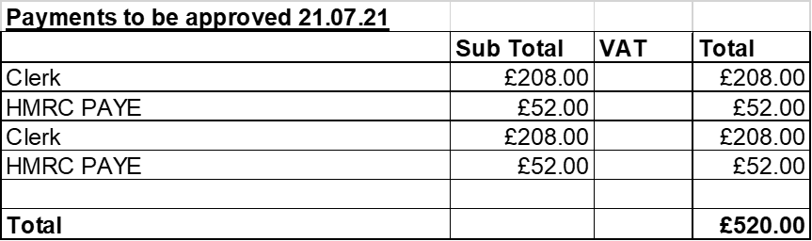  Approval also to pay any invoices that should be presented during August to avoid late payment fees. Clerk will advise Chairman and Vice Chairman if there are any.  Approval to pay B Holmes invoice for village maintenance once we receive it, estimate £300 - £400.  - To approve monthly bank reconciliation - Approved  - To receive report on performance against budget - Approved
15 | Councillor Information and items for the next Agenda  Lawnmower replacement to be considered – quotes will be presented to the council at the next meeting estimated £400.  Village parking – Invite local PCSO to a future meeting it is envisaged as the start of regular liaison visits to cover any relevant police-related matters (including parking that causes a dangerous obstruction).
16 | To agree date of next meeting  22nd September @ 7.30pm Hilderstone Village Hall
17 | Meeting Closed – The chairman thanked everyone for attending and closed the meeting at 8.40pm

