**RFO Finance Report 24.03.2021**

**Item 12 Finance**

1. To approve the monthly to be made payments – a separate form will be sent for two members to authorise RFO to make the payments.

|  |  |
| --- | --- |
| Payments to be made from 24.03.21 |  |
| Clerk Office Exp 01.03.21 to 31.03.21 | £42.55 |
| Creswell PC - zoom | £3.59 |
| SPCA | £193.00 |
| WH Holmes | £85.00 |
| **Total** | **£324.14** |
|  |  |
| plus salaries |  |

1. To approve monthly bank reconciliation, see page 2
2. To receive report on performance against budget 2020/21, see page 4
3. To approve 2021/22 Budget, see page 6

**Bank reconciliation 17.03.21**

Balance as per statement on 17.03.21 £17,549.38

Less unpresented payments £481.14

Total as per cashbook £17,068.24



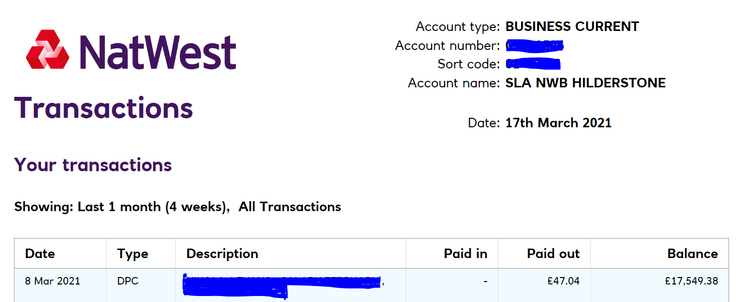

|  |  |  |  |  |  |  |  |
| --- | --- | --- | --- | --- | --- | --- | --- |
|  |  |  | Budget monitoring for 2020/21 |  |  |  |  |
|  |  |  | Income | Budget | Actual | Difference |  |
| Refunds | £191.60 |  | Refunds | £0.00 | 191.60 | -191.60 |  |
| Bank interest | £0.00 |  | Bank interest |  | 0.00 | 0.00 |  |
| Vat reclaim | £604.00 |  | Vat reclaim |  | 604.00 | -604.00 |  |
| Precept | £11,533.00 |  | Precept | £11,533.00 | 11,533.00 | 0.00 |  |
| **Total** | **£12,328.60** |  | **Total** |  |  | **-604.00** |  |
|  |  |  | Expenditure | Budget | Actual | Difference |  |
| Salaries inc PAYE | £3,264.58 |  | Salaries inc PAYE | £3,918.00 | 3,264.58 | 653.42 |  |
| Clerk/office Expenses | £1,167.80 |  | Clerk/office Expenses | £688.00 | 1,167.80 | -479.80 |  |
| Chairman's Allowance | £361.00 |  | Chairman's Allowance | £361.00 | 361.00 | 0.00 |  |
| Councillor Expenses | £0.00 |  | Councillor Expenses | £50.00 | 0.00 | 50.00 |  |
| Subscriptions | £435.31 |  | Subscriptions | £240.00 | 435.31 | -195.31 |  |
| Training | £25.00 |  | Training | £120.00 | 25.00 | 95.00 |  |
| Audit | £50.00 |  | Audit | £100.00 | 50.00 | 50.00 |  |
| Insurance | £220.84 |  | Insurance | £300.00 | 220.84 | 79.16 |  |
| Registration - Information Commissioner | £35.00 |  | Registration - Information Commissioner | £50.00 | 35.00 | 15.00 |  |
| Village Hall Office Space | £579.00 |  | Village Hall Office Space | £579.00 | 579.00 | 0.00 |  |
| Election Reserves | £0.00 |  | Election Reserves | £3,500.00 | 0.00 | 3,500.00 |  |
| Grounds/Village Maintenance | £1,060.15 |  | Grounds/Village Maintenance | £3,358.00 | 1,060.15 | 2,297.85 |  |
| Tree Surgery Work | £0.00 |  | Tree Surgery Work | £300.00 | 0.00 | 300.00 |  |
| Church Burial Ground | £469.00 |  | Church Burial Ground | £469.00 | 469.00 | 0.00 |  |
| Community grants | £30.00 |  | Community grants | £250.00 | 30.00 | 220.00 |  |
| Highways | £2,791.46 |  | Highways | £7,196.00 | 2,791.46 | 4,404.54 | inc SSRP grant |
| Rights of Way Repairs | £0.00 |  | Rights of Way Repairs | £170.00 | 0.00 | 170.00 |  |
| Section 137 | £21.98 |  | Section 137 | £100.00 | 21.98 | 78.02 |  |
| Precept | £0.00 |  | Precept | £0.00 | 0.00 | 0.00 |  |
| Concurrent | £0.00 |  | Concurrent | £0.00 | 0.00 | 0.00 |  |
| Bank interest | £0.00 |  | Bank interest | £0.00 | 0.00 | 0.00 |  |
| Best Kept Village | £0.00 |  | Best Kept Village | £150.00 | 0.00 | 150.00 |  |
| Reserves | £0.00 |  | Reserves | £4,428.00 | 0.00 | 4,428.00 | inc christmas party funds |
| Refunds | £0.00 |  | Refunds |  | 0.00 | 0.00 |  |
| **Total** | **£10,511.12** |  | **Total** |  |  | **15,162.46** |  |
|  | |  |  |  |  |  |  |
| Excess of income over expenditure | **£1,817.48** |  |  |  |  |  |  |
| balance BF 2019/20 | £15,250.76 |  |  |  |  |  |  |
| plus income | £27,579.36 |  |  |  |  |  |  |
| less expenditure | £17,068.24 |  |  |  |  |  |  |
| Total | **£17,068.24** |  |  |  |  |  |  |

|  |  |  |
| --- | --- | --- |
| Budget 2021/22 |  |  |
|  |  |  |
| **Income** | **Budget** |  |
| Refunds | £0.00 |  |
| Bank interest | £0.00 |  |
| Vat reclaims | £0.00 |  |
| Precept | £11,699.00 |  |
| **Total** | **£11,699.00** |  |
|  |  |  |
| **Expenditure** | **Budget** |  |
| Salaries inc PAYE | £3,984.00 |  |
| Clerk/office Expenses | £688.00 |  |
| Chairman's Allowance | £361.00 |  |
| Councillor Expenses | £50.00 |  |
| Subscriptions | £260.00 |  |
| Training | £150.00 |  |
| Audit | £150.00 |  |
| Insurance | £300.00 |  |
| Registration - Information Commissioner | £50.00 |  |
| Village Hall Office Space | £110.00 |  |
| Election Reserves | £3,500.00 | added Fin regs state we should keep £3500 in reserves for Elections |
| Grounds/Village Maintenance | £3,358.00 |  |
| Tree Surgery Work | £0.00 |  |
| Church Burial Ground | £938.00 |  |
| Community grants | £250.00 |  |
| Highways | £5,204.54 | includes 4404.54 carry over from 2020/21 from SSRP |
| Rights of Way Repairs | £170.00 |  |
| Section 137 | £100.00 |  |
| Best Kept Village | £150.00 |  |
| Reserves | £4,428.00 | includes xmas party carry over |
| **Total** | **£24,201.54** |  |
|  |  |  |
| Estimated Carry over from 2021 | £16,908.10 |  |
| Precept request for 2021/22 | £11,699.00 |  |
| **Total** | **£28,607.10** |  |
| Estimated carry over for 2022/23 | £4,405.56 |  |